

**American International University-Bangladesh (AIUB)**  
 Department of Computer Science

Faculty of Science & Technology (FST)

**PROJECT TITLE**

**Agro Trade Transparency System**

**Semester: Fall 25-26**

|  |  |  |
| --- | --- | --- |
| ***Group:*** | | ***Section:*** |
| **SL** | **Student Name** | **Student ID** |
| 1 | Md. Towhidul Islam | 23-55036-3 (26) |
| 2 | Aditya Roy | 23-55077-3 (29) |
| 3 | Md. Rabbi Ahmed | 23-55450-3 (34) |
| 4 | Sajal Kumar Ghosh | 23-55419-3 (33) |
| 5 |  |  |

Table of Contents

1. Project Proposal 03-05

1.1 Background to the Problem 03

1.2 Selection of Process Model 04-05

2. Software Requirements Specification (SRS) / PRD xx

2.1 Scopes and Features xx

2.2 User Story Table xx

2.3 Requirements Traceability Matrix xx

2.3.1 Functional Requirements xx

2.3.2 Non-Functional Requirements xx

3. Software Design xx

3.1 System Deisgn xx

3.2 UI Deisgn using Figma xx

4. Git Workflow xx

5. Software Testing xx

6. Conclusion xx

1. **PROJECT PROPOSAL**



* 1. **Background to the Problem**

In Bangladesh and many developing countries, the agricultural supply chain faces serious problems that hurt both farmers and consumers.

**The Current Situation**

Nearly 40% of Bangladesh's workforce works in agriculture, but the system is broken. Farmers often sell their vegetables and crops at very low prices, sometimes 30-40% below what they should get. At the same time, consumers in cities pay much higher prices for the same products. The money doesn't go to the farmers; instead, middlemen take most of the profit.

**Main Problems**

**Unfair Pricing:** Middlemen control the market and manipulate prices. Farmers have no power to set fair prices for their hard work, while consumers pay inflated costs.

**Lack of Transparency:** Most transactions happen in cash with no proper records. This makes it easy for corrupt practices to continue without anyone being held accountable. There's no way to track where products come from or how prices are set.

**No Digital System:** There is currently no centralized platform where farmers can see real time market prices, connect directly with buyers, or track their products. This leaves everyone: farmers, traders, and consumers in the dark.

**Recent Crisis Examples:** Events like the 2023 rice price surge and 2024 vegetable market volatility showed how badly the system works. Farmers sometimes must throw away their produce because they can't sell it, while consumers face sudden price shocks.

**Why This Matters**

This broken system creates several serious issues:

1. **Financial Loss for Farmers:** They can't earn what they deserve for their hard work
2. **Higher Living Costs:** Consumers pay more than necessary for basic food items
3. **Economic Instability:** The entire agricultural economy suffers from this inefficiency
4. **Loss of Trust:** Nobody trusts the system; not farmers, not consumers, not even traders
   1. **Selection of Process Model**

**Selected Process Model: Agile Scrum**

For the development of the Agro Trade Transparency System, the Agile Scrum process model has been selected. Scrum is an iterative and incremental software development framework that supports flexibility, continuous feedback, and collaboration, making it suitable for a dynamic system like agricultural trade.

Scrum develops software in short cycles called Sprints, usually lasting 1-4 weeks. Each Sprint delivers a working and testable part of the system. Instead of building everything at once, Scrum allows gradual development and improvement based on feedback.

According to the Scrum model, the process is divided into three main phases:

* **Pre Game Phase:** System planning, creation of the Product Backlog, requirement prioritization, and high-level architecture design.
* **Development (Game) Phase:** Development is carried out in Sprints with regular Daily Scrum meetings, coding, and testing.
* **Post Game Phase:** Final integration, system testing, documentation, and preparation for release.

**Roles and Responsibilities in Scrum**

* **Product Owner:** Manages and prioritizes the Product Backlog and makes final decisions on features
* **Scrum Master:** Ensures Scrum rules are followed and removes obstacles
* **Scrum Team:** Developers who design, implement, test, and deliver the system
* **Stakeholders:** Provide feedback and requirements
* **Management:** Supports decision-making and project goals

**Reasons for Choosing Agile Scrum**

**1. Flexibility and Adaptability**

The agricultural trade environment is constantly changing due to price variations, government regulations, and farmer needs. Scrum allows the system to be updated easily based on these changes, making it ideal for the Agro Trade Transparency System.

**2. Continuous User Feedback**

Farmers, traders, retailers, and government representatives can provide feedback after each Sprint. This ensures the system meets real world agricultural market requirements.

**3. Incremental Development**

The system includes complex features such as blockchain transactions, mobile payments, and supply chain tracking. Developing these features in small Sprints reduces risk and improves quality.

**4. Strong Team Collaboration**

Scrum promotes regular communication through daily meetings and reviews. This helps maintain transparency and alignment among all team members.

The Agile Scrum process model is the most appropriate choice for the Agro Trade Transparency System because it ensures flexibility, continuous user involvement, efficient collaboration, and timely delivery of working software. It effectively supports the development of a reliable and transparent agricultural trading platform.

## 2. SOFTWARE REQUIREMENTS SPECIFICATIONS (SRS) / PRODUCT REQUIREMENTS DOCUMENT (PRD)

**2.1 Scopes and Features**

**Scope of the System**

The Agro Trade Transparency System aims to build a transparent, fair, and digital agricultural trading platform. It connects farmers, traders, buyers, consumers, payment agents, and government authorities in one system.

The system focuses on:

* Ensuring fair pricing for farmers
* Reducing middleman exploitation
* Enabling secure digital payments
* Providing supply chain transparency
* Allowing government monitoring of trade activities

This system improves trust, efficiency, and accountability in agricultural trade.

**Key Features**

* **User Management**: Secure login and role based access for all users
* **Digital Transactions**: All trades are recorded digitally with unique IDs
* **Payment System**: Mobile wallet payments (bKash, Nagad) with direct farmer payout
* **Supply Chain Tracking**: Track products from farm to consumer using IDs
* **Market Price Transparency**: Real time and historical price display
* **Government Dashboard**: Monitoring of prices, trades, and policy compliance
* **User Friendly Interface**: Mobile first design with Bangla language support

**Future Scope**

* AI based price prediction
* Expansion to other agricultural sectors
* Advanced analytics and reporting
* Integration with logistics and more payment gateways

**2.2 User Story Table**

|  |  |  |  |
| --- | --- | --- | --- |
| **As A / An** | **I Want To** | **So That** | **Acceptance Criteria** |
| Farmer | Create a farmer profile | I can enroll myself in the system | OTP is sent to the farmer’s mobile number and a confirmation email is sent |
| Farmer | Log in using mobile number and password | The system can authenticate me securely | After successful login, farmer-related data is accessible |
| Farmer | View my profile details | I can see my registration information | Profile information table is displayed with edit option |
| Farmer | Update my profile information | My information remains correct | Updated information is saved and shown successfully |
| Farmer | View current market prices | I can sell products at a fair price | Real time market price list is displayed |
| Farmer | Receive digital payments | I get paid safely and quickly | Payment confirmation is shown and transaction is recorded |
| Trader | Create a trader account | I can participate in digital trading | OTP verification and email confirmation are completed |
| Trader | Log in to the system | I can access trading features | Trader dashboard loads after successful login |
| Trader | Purchase agricultural products | Transactions are transparent | Digital transaction record is generated |
| Trader | View supply chain status | I can track product movement | Real time tracking status is displayed |
| Delivery Agent | Create a delivery agent profile | I can deliver products officially | OTP and confirmation email are sent |
| Delivery Agent | Update delivery status | Buyers and sellers know product location | Delivery status is updated in real time |
| Buyer | View product details | I can verify product source | Product origin and history are displayed |
| Buyer | Make digital payments | Transactions are secure and cashless | Payment success message and receipt are generated |
| Buyer | Scan product QR code | I can check product authenticity | Product traceability information is shown |
| Government Officer | Log in as authority user | I can monitor the agricultural market | Secure access to monitoring dashboard |
| Government Officer | Monitor market prices | Price manipulation is reduced | Price data is shown with alerts |
| Government Officer | View transaction reports | I can ensure transparency | Transaction and trade reports are generated |
| Admin | Manage user accounts | The system runs smoothly | Add, update, or remove users with confirmation |
| Admin | Manage system data | Data remains accurate and secure | Successful update notification is shown |

**2.3 Requirements Traceability Matrix**

**2.3.1 Functional Requirements**

|  |  |
| --- | --- |
| **Module** | **Key Features** |
| User Management | The system shall allow farmers to register using OTP verification |
| Authentication | The system shall authenticate users using login credentials |
| Profile Management | The system shall allow users to view and update their profile |
| Market Price Module | The system shall display real time market prices |
| Payment System | The system shall support digital payment transactions |
| Transaction Module | The system shall record all trade transactions digitally |
| Supply Chain Tracking | The system shall track products across the supply chain |
| Traceability | The system shall allow buyers to verify product source |
| Government Dashboard | The system shall provide monitoring dashboards for government officers |
| Admin Module | The system shall allow admin to manage users and system data |

**2.3.2 Non-Functional Requirements**

|  |  |
| --- | --- |
| **Non-Functional Requirement** | **Description** |
| Performance | System response time shall be less than 3 seconds for common operations |
| Security | OTP based authentication and encrypted transactions must be used |
| Availability | System shall be available 24/7 with minimal downtime |
| Scalability | System shall support increasing number of users and transactions |
| Usability | Interface shall be simple and support Bangla language |
| Reliability | Transactions shall not be lost during network failure |
| Maintainability | System shall support easy updates and bug fixes |
| Compatibility | System shall work on web and mobile platforms |
| Data Integrity | Stored data shall remain accurate and consistent |
| Auditability | All transactions shall be logged for government review |

# 3. SOFTWARE DESIGN

**3.1 System Design:** Draw the system design for your project using **Draw.io** or **LucidChart**.

**Use Case Diagram :**

**Actors:**  
User, Farmer, Trader, Agent, Consumer, Transport, Buyer, Seller.

**Use Cases:** Submit Product, List Product for Sale, Browse Product List, View Product Details, Make Purchase, Initiate Trade Transaction, Payment, Verify Transaction, Access Trade History, View Market Price, Check Product Traceability, Update Product Shipping, Track Product Delivery, Confirm Product Receipt, Transaction Receipts.

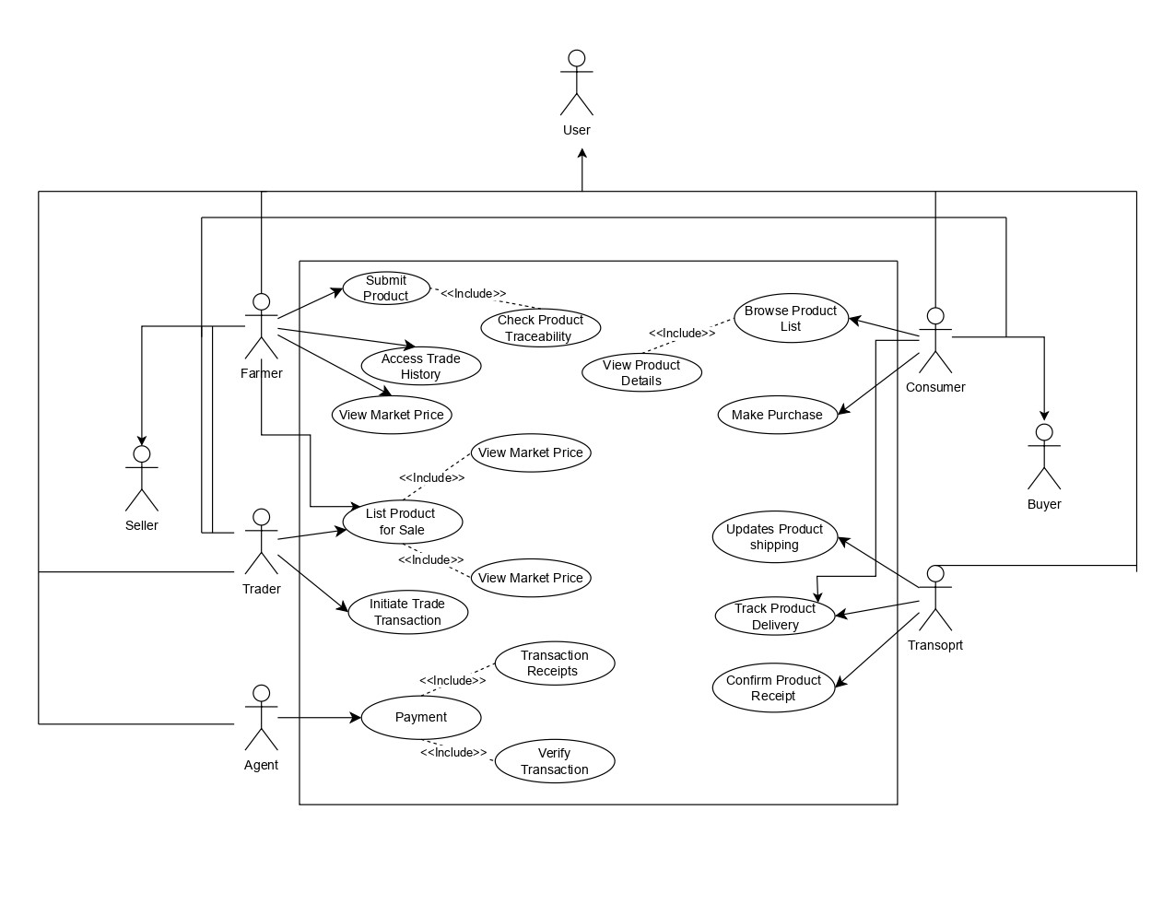

Fig : Use Case Diagram

**Actors and Roles**

**Farmer**  
Initiates the supply chain by submitting products to the marketplace, checking product traceability to ensure transparency, accessing trade history for record keeping, and viewing market prices to make informed pricing decisions.

**Trader**  
Acts as an intermediary facilitator who lists products for sale on the platform, initiates trade transactions between buyers and sellers, and monitors market prices to enable competitive trading.

**Consumer**  
Represents end users who browse the product list to discover available items, view detailed product information including origin and quality specifications, and make direct purchases through the platform.

**Buyer**  
Represents wholesale or bulk purchasers who engage in larger scale transactions within the marketplace ecosystem.

**Transport**  
Manages the logistics and delivery operations by updating product shipping status, tracking product delivery throughout the transit process, and confirming product receipt upon successful delivery.

**Agent**  
Handles the financial infrastructure by processing payments securely and verifying transaction completion to ensure trust in the trading process.

**Relationships**

**<<include>>**

These show mandatory dependencies where one use case always requires another:

* **Submit Product** includes **Check Product Traceability** (product submission requires traceability verification).
* **Browse Product List** includes **View Product Details** (browsing inherently provides access to detailed information).
* **List Product for Sale** includes **View Market Price** (listing requires current market price information).
* **Initiate Trade Transaction** includes **View Market Price** (trade initiation depends on market price data).
* **Payment** includes **Verify Transaction** (payment processing always requires transaction verification).
* **Payment** includes **Transaction Receipts** (completed payments always generate receipts).

**Generalization**

The diagram shows actors with different roles operating within the same system boundary, where specialized actors like Farmer, Trader, and Consumer share common platform features but have distinct functional access based on their role in the supply chain.

**Class Diagram :**

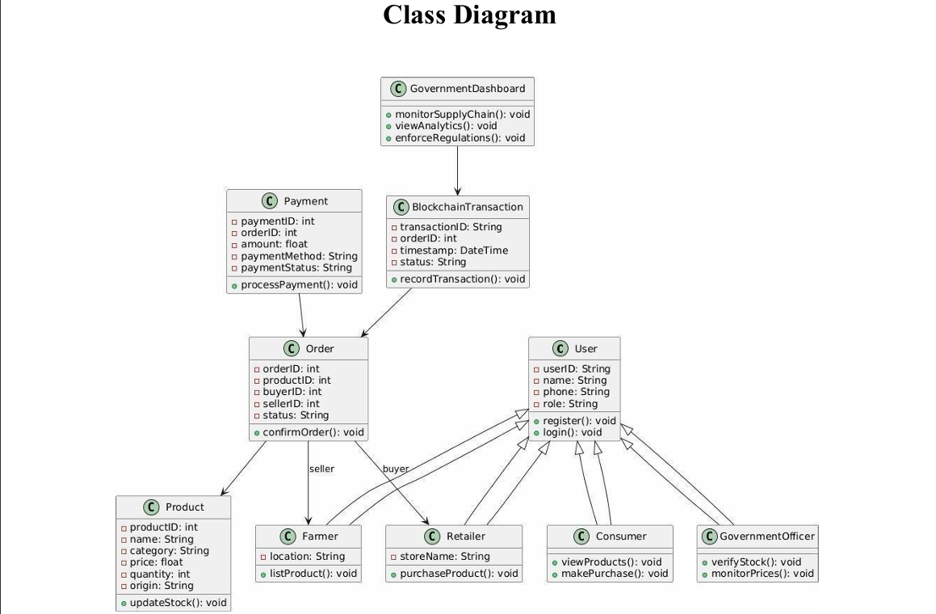

This class diagram represents a blockchain-based e-commerce monitoring system involving users, transactions, and government oversight. The system includes core classes such as User, Order, Payment, Product, and BlockchainTransaction, which together manage product listing, purchasing, payment processing, and secure transaction recording. Users are categorized into Consumer, Retailer, Farmer, and GovernmentOfficer, each with specific roles and functionalities. The GovernmentDashboard and GovernmentOfficer classes enable monitoring, analysis, and regulation enforcement to ensure transparency and fair pricing. Overall, the diagram illustrates how blockchain technology is integrated to provide secure, traceable transactions and effective regulatory supervision.

**Activity Diagram :**

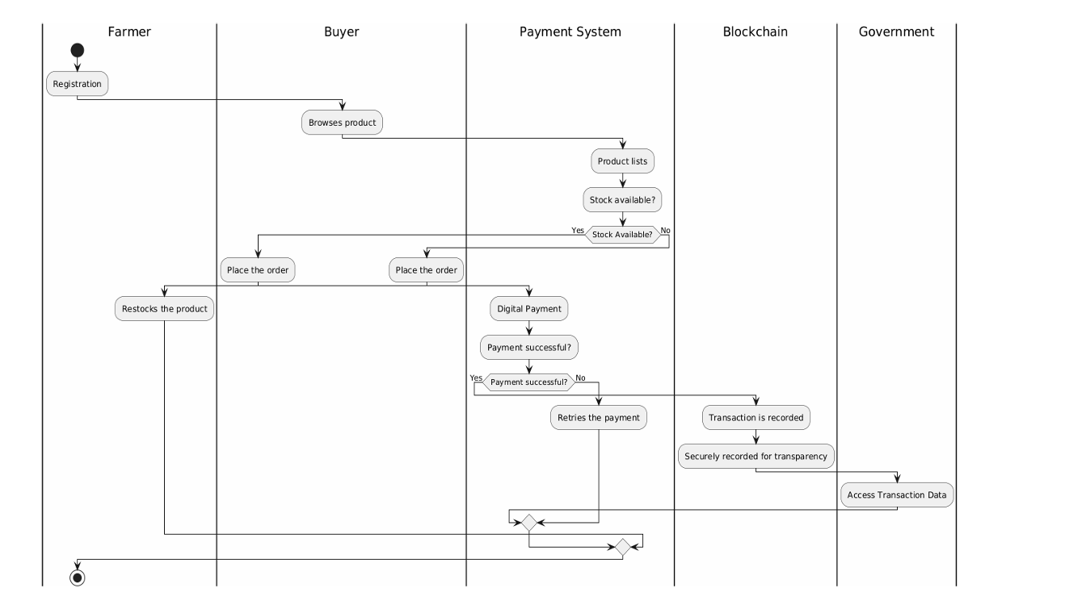

This activity diagram illustrates the end-to-end workflow of a blockchain-enabled agricultural e-commerce system involving the Farmer, Buyer, Payment System, Blockchain, and Government. The process begins with farmer registration and product listing, after which the buyer browses available products and checks stock availability. If stock is available, the buyer places an order and proceeds with digital payment. Upon successful payment, the transaction is securely recorded on the blockchain to ensure transparency and immutability. In case of payment failure, the system allows retrying the payment. Farmers can restock products when necessary, and the government can access transaction data from the blockchain for monitoring and regulatory purposes. Overall, the diagram highlights a transparent, secure, and regulated transaction flow.

## UI / Wireframe Design using Figma

**Trello Board :**

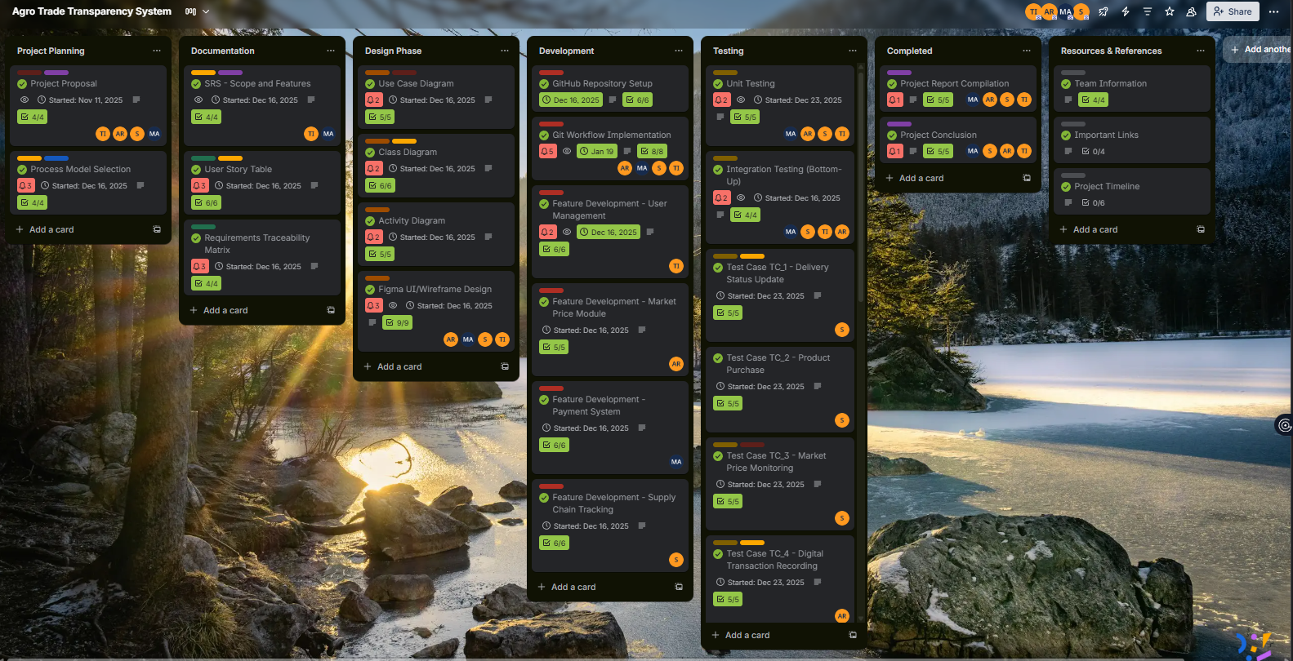

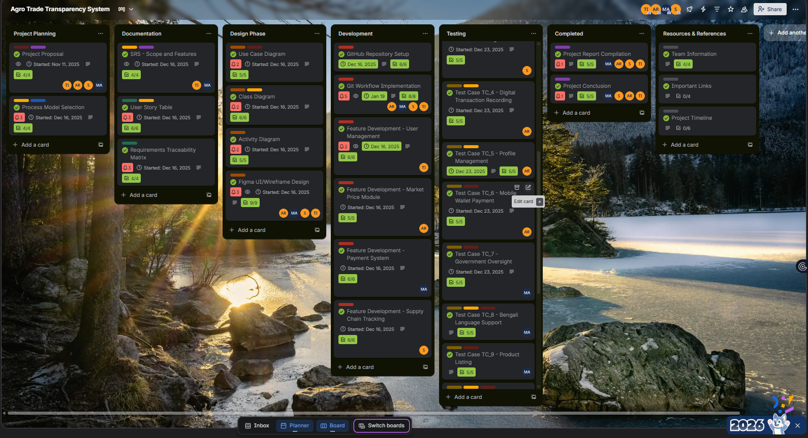

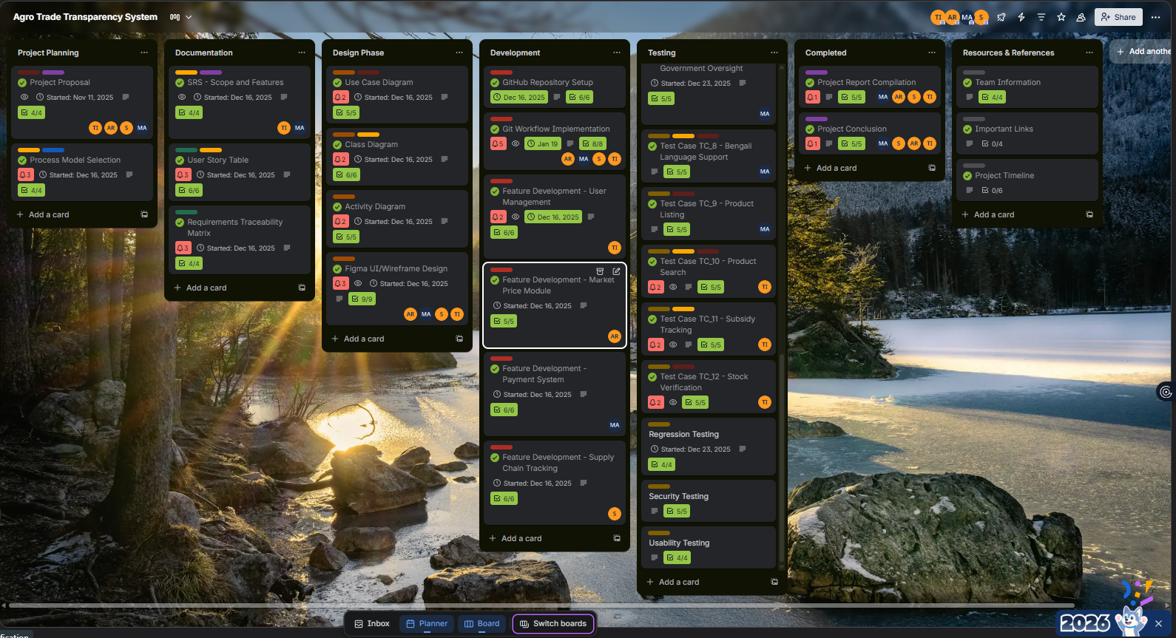

Trello Board

**Figma Design :**

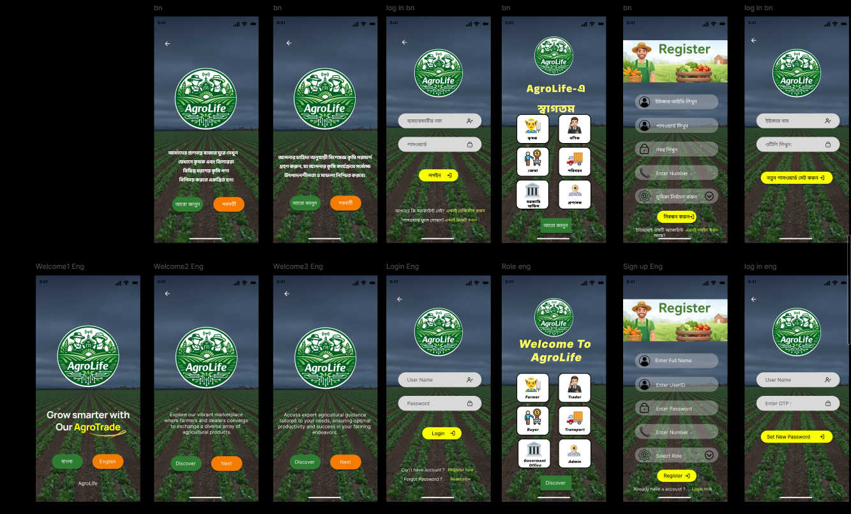

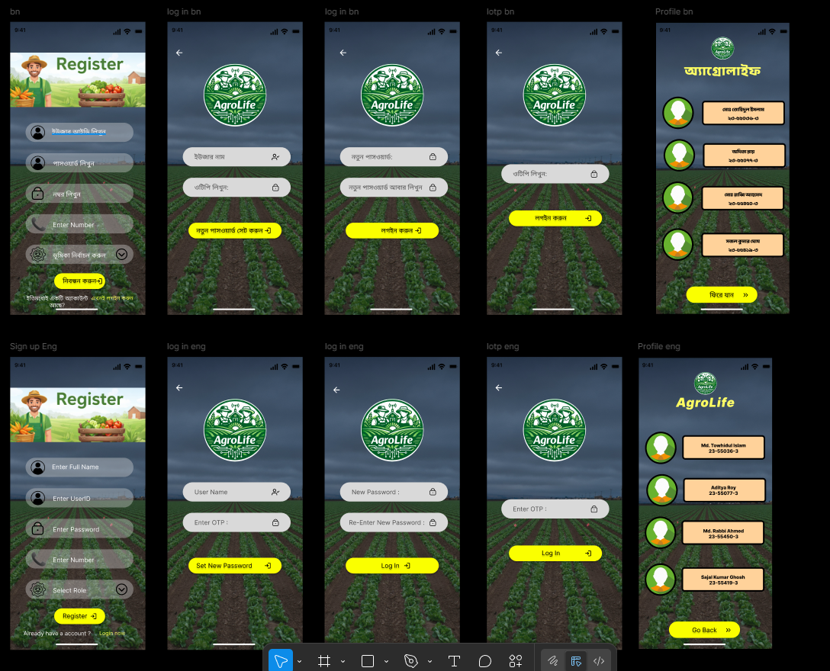

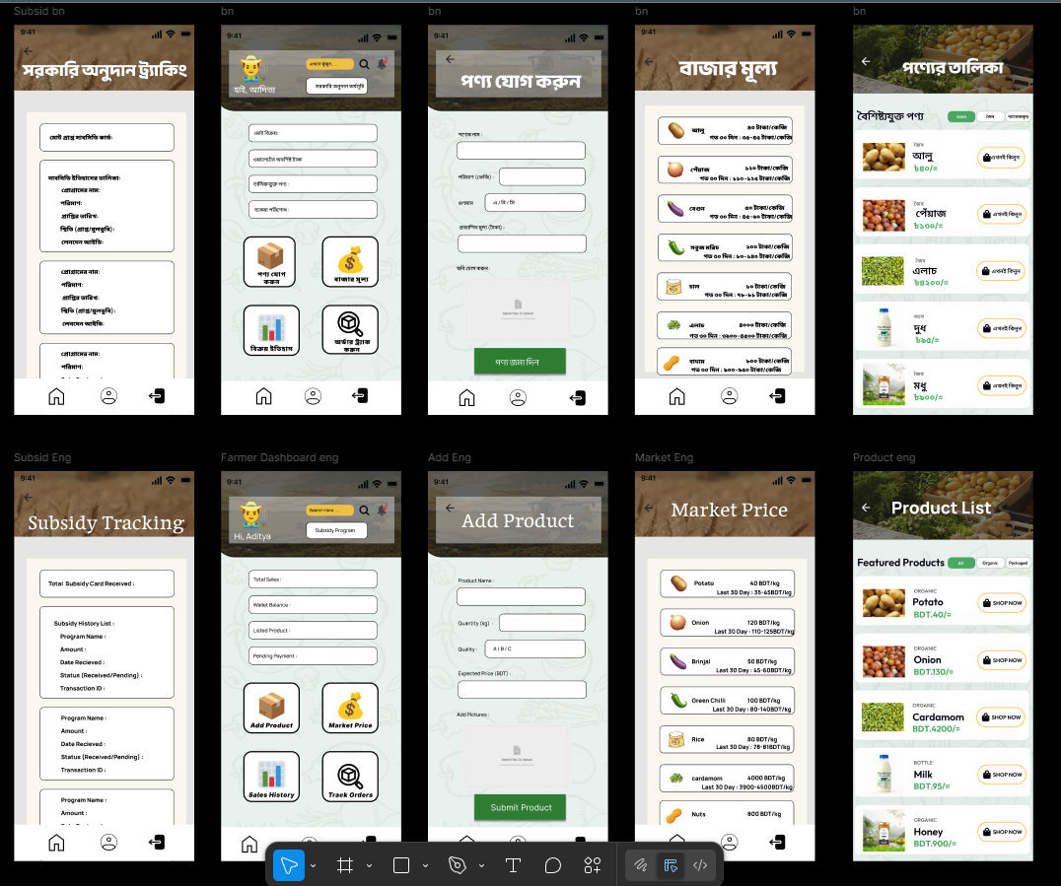

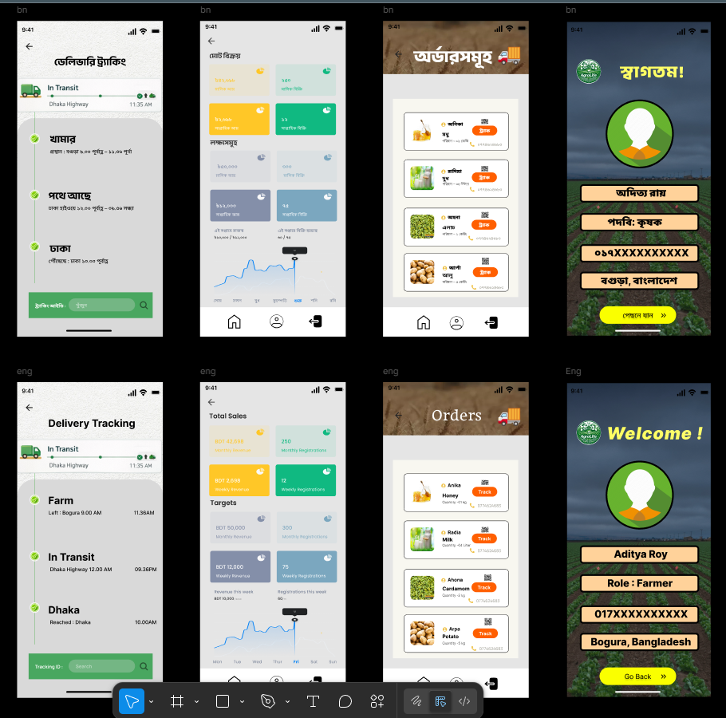

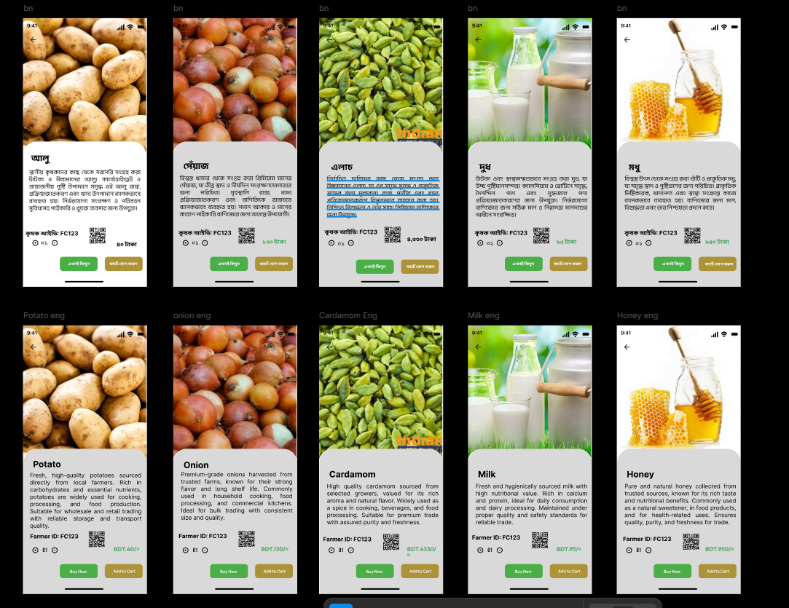

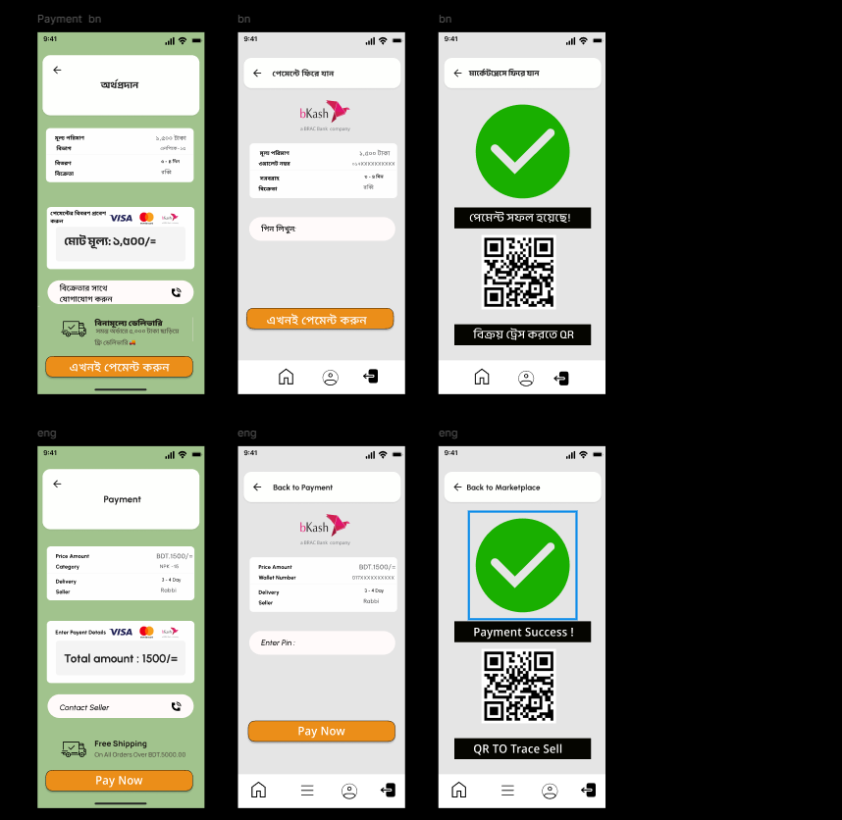

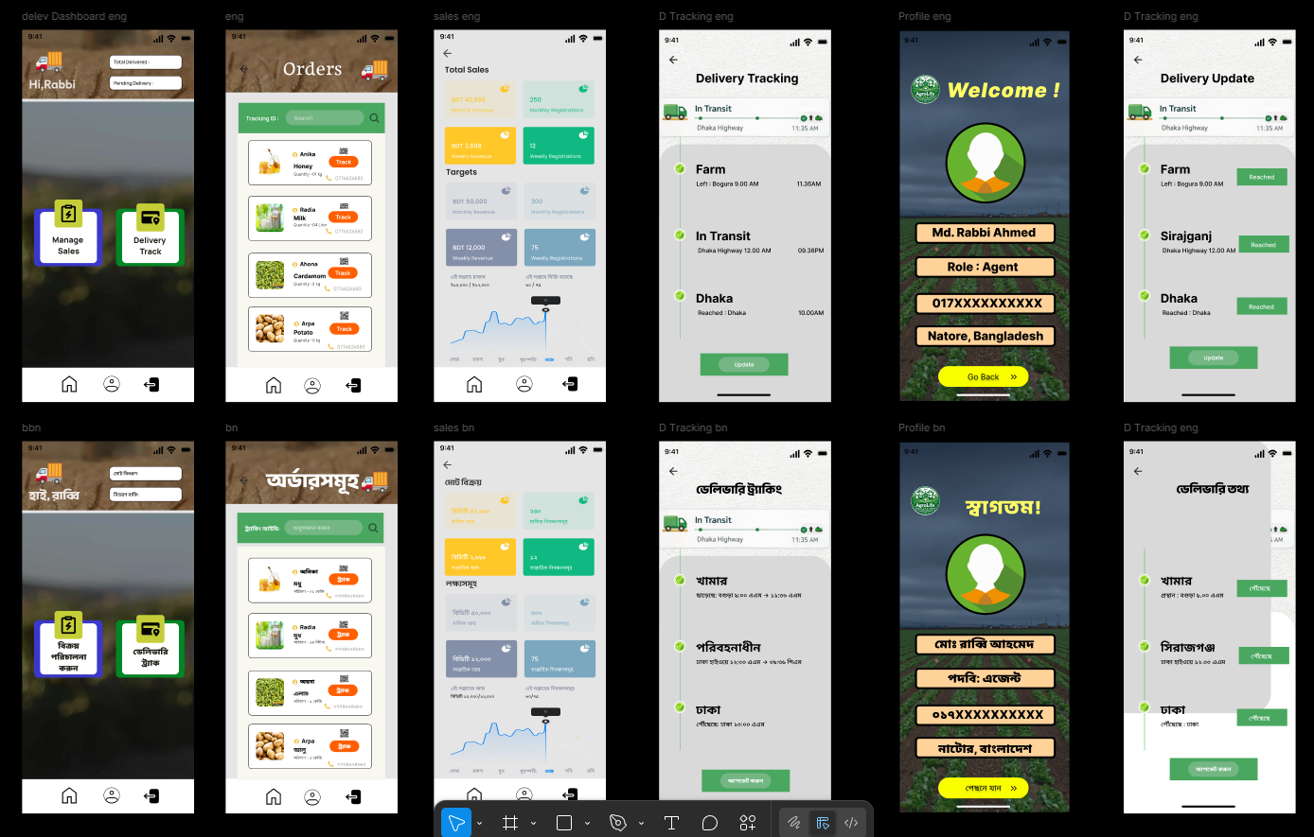

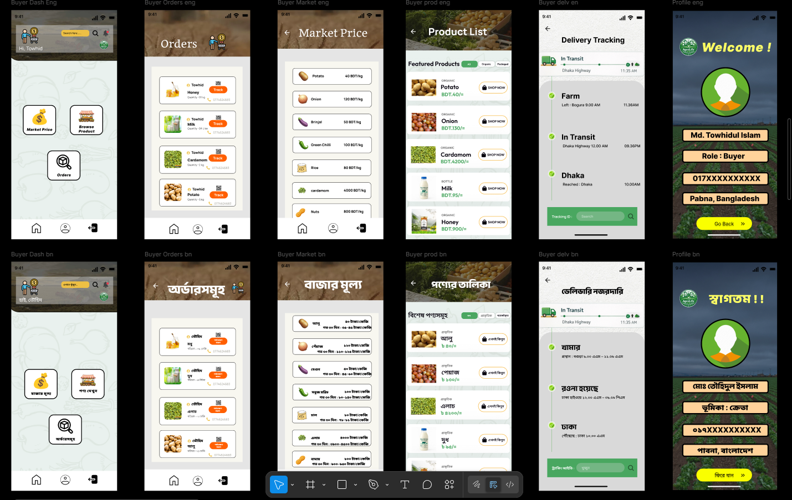

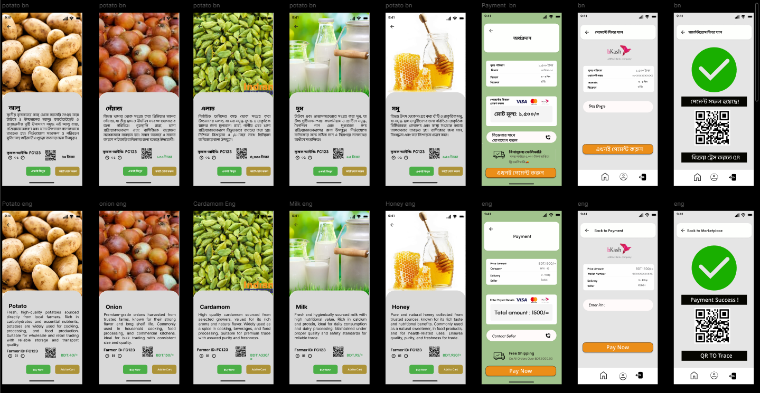

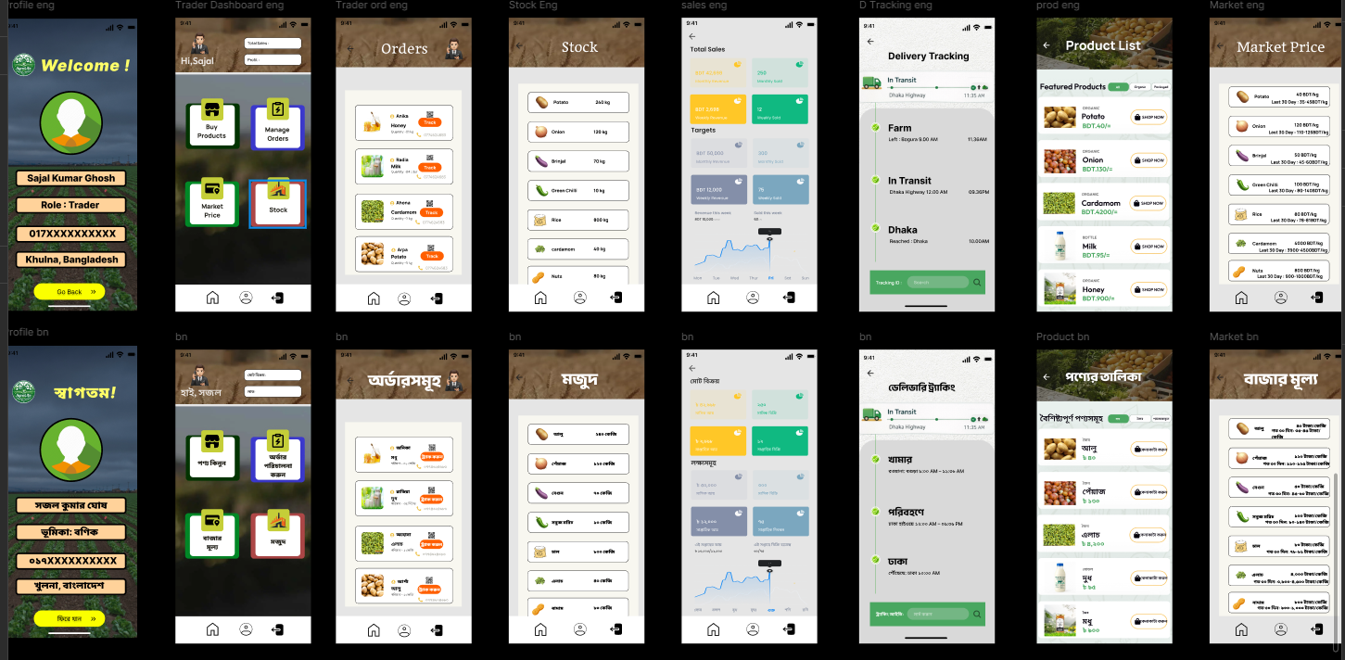

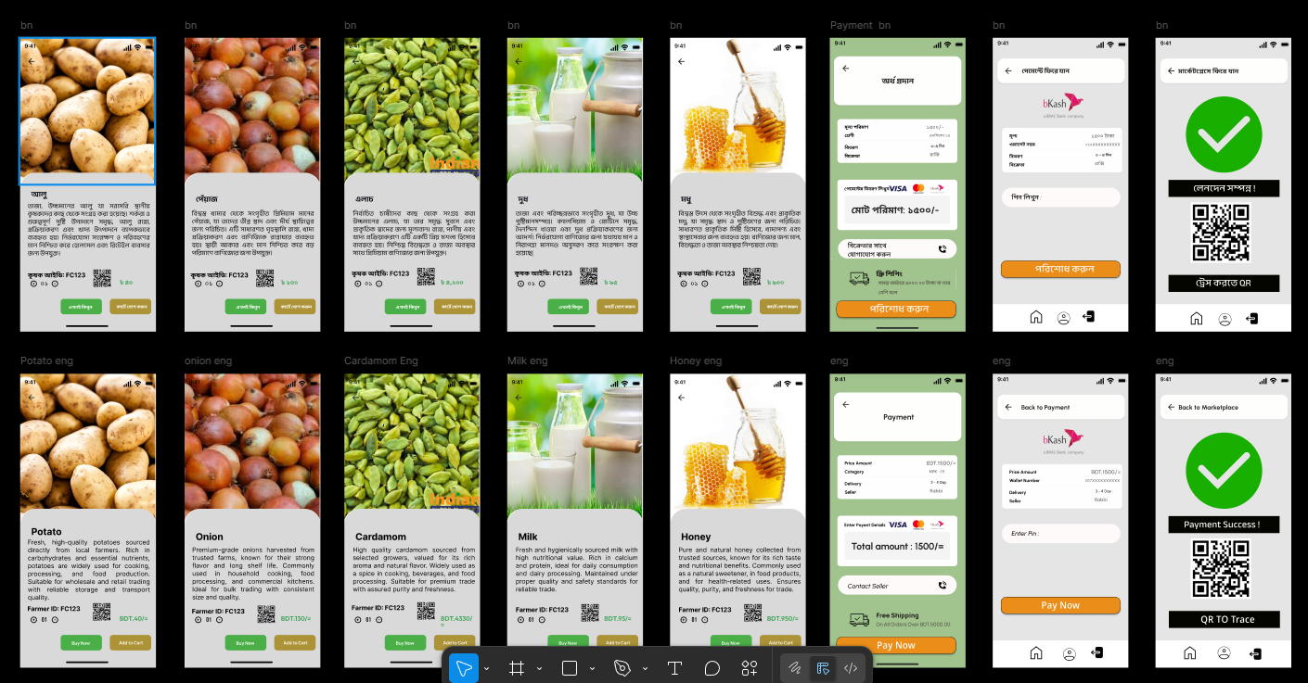

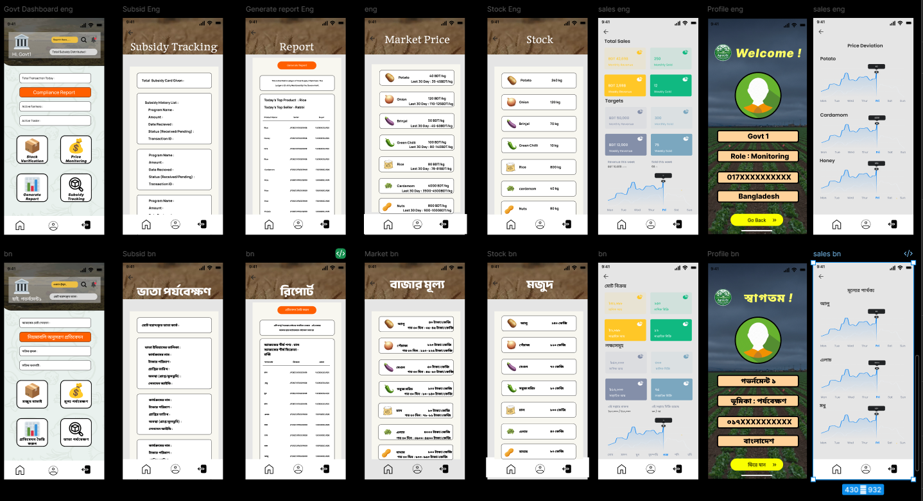

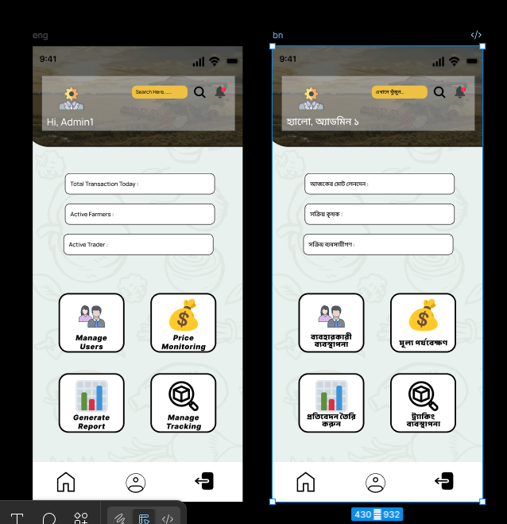

# 4. GIT WORKFLOW

Git Repo

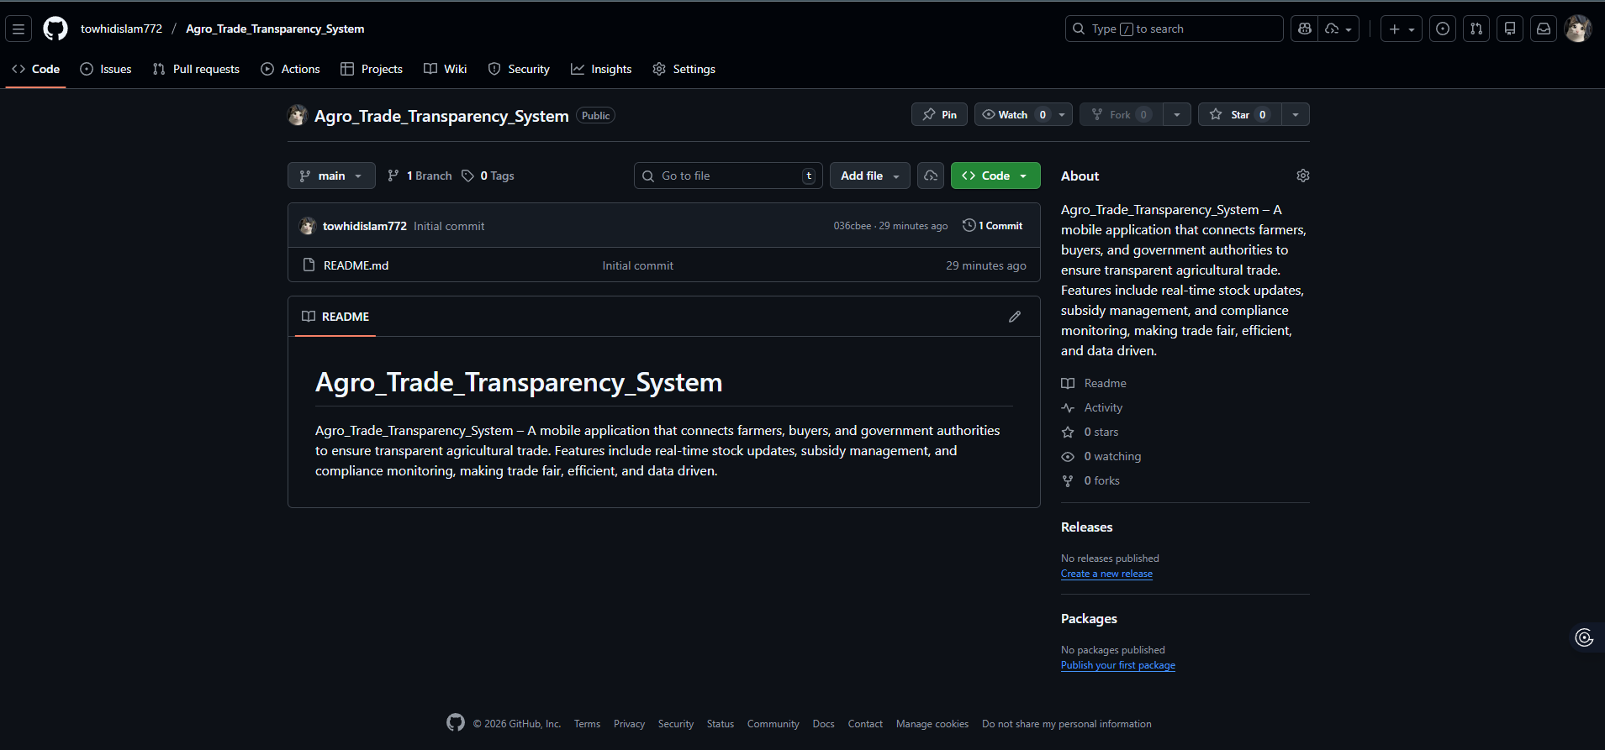

Git Clone

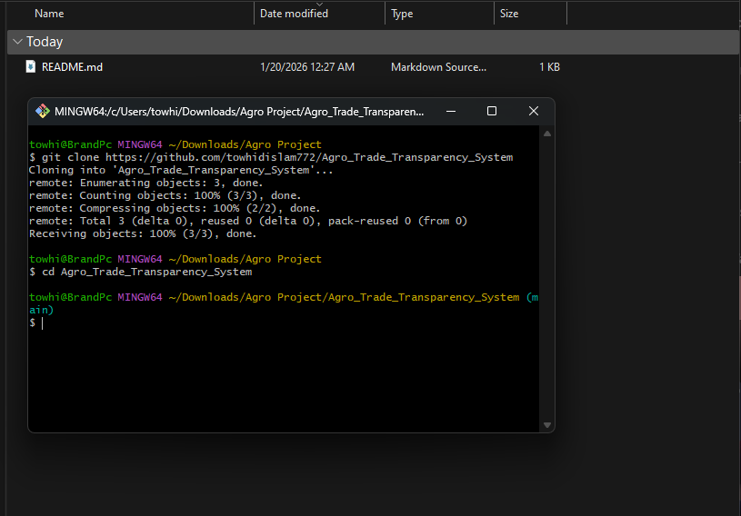

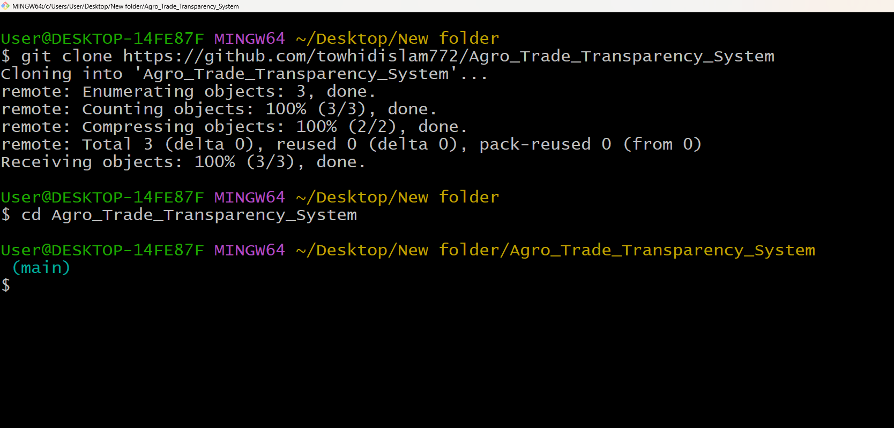

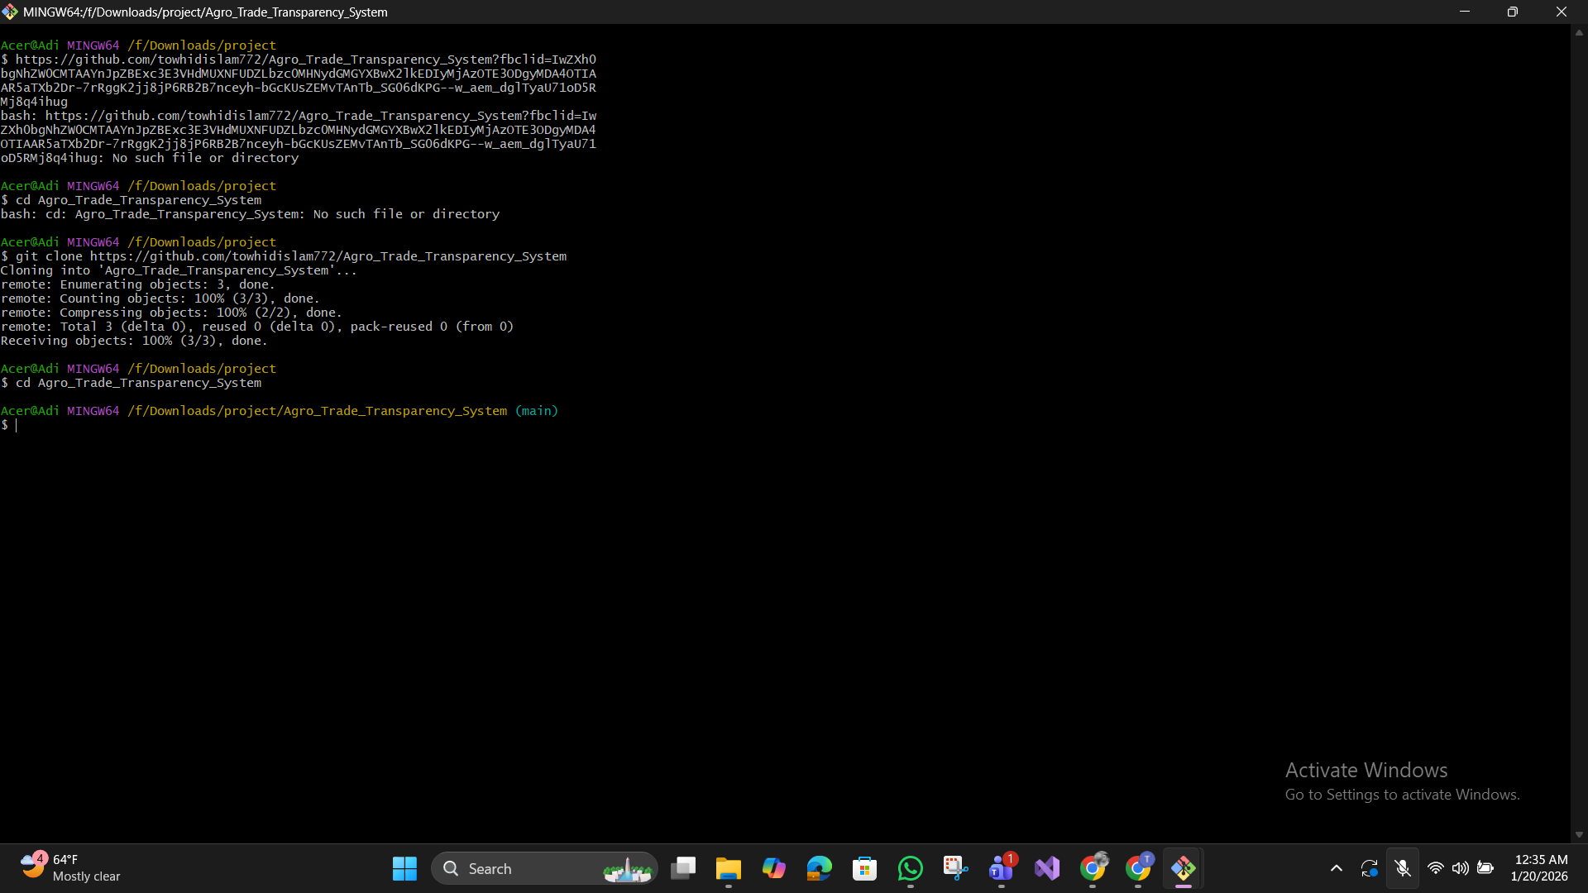

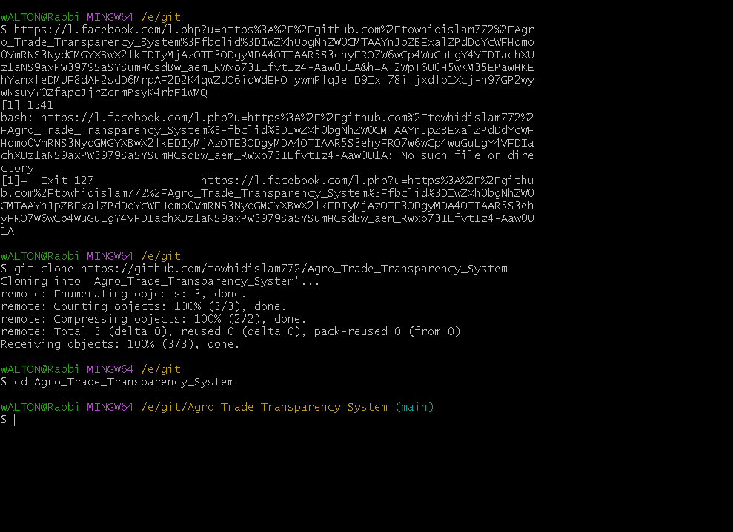

Create future Branches

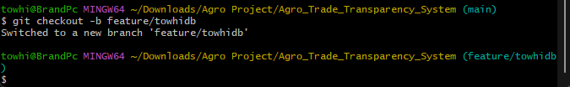

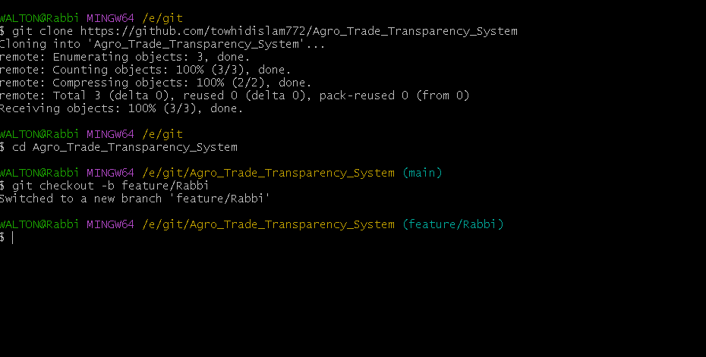

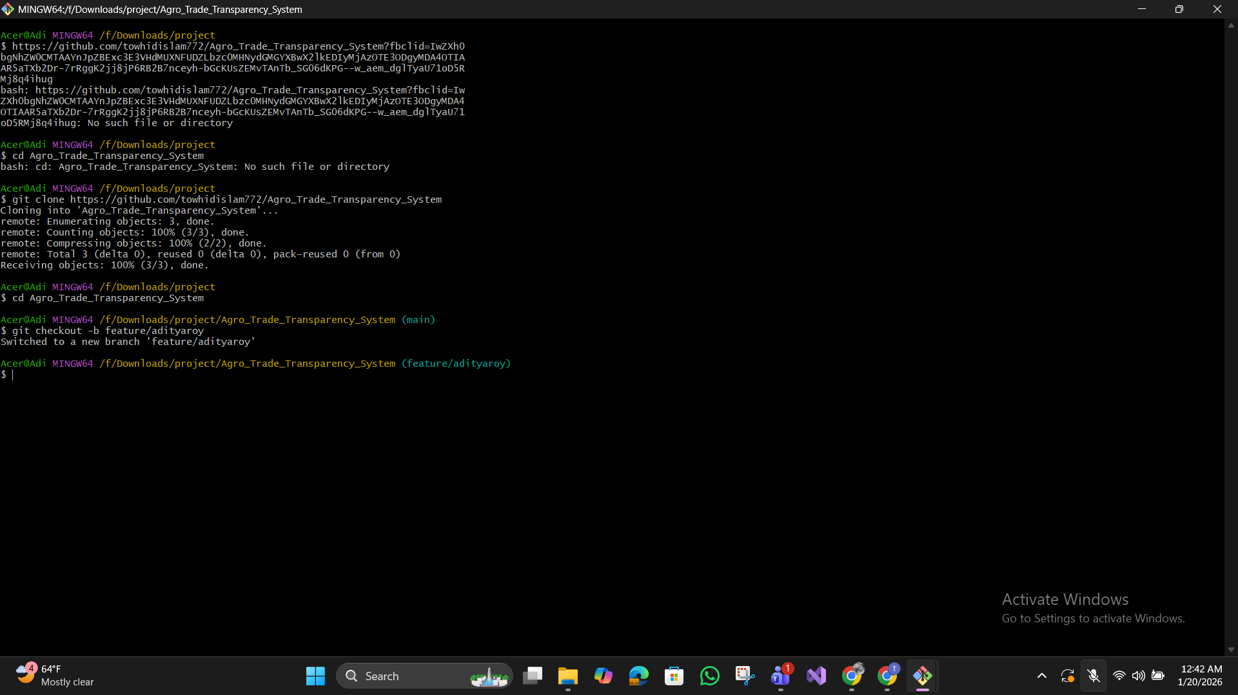

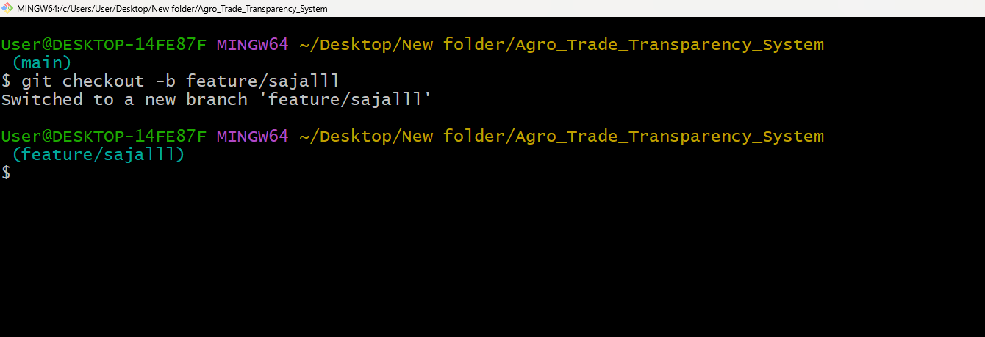

Commit Changes :

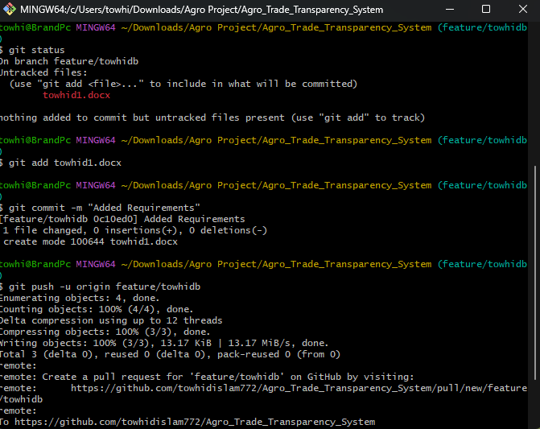

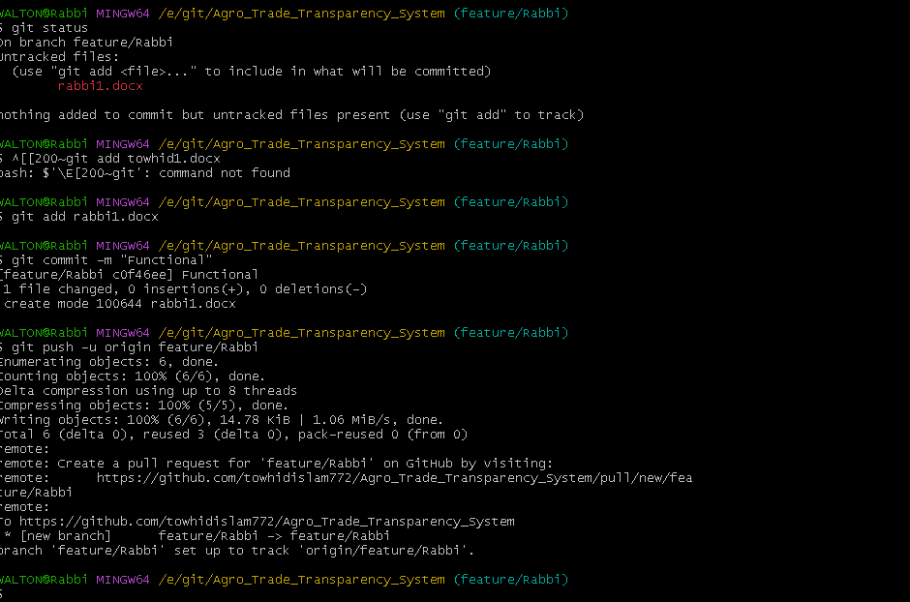

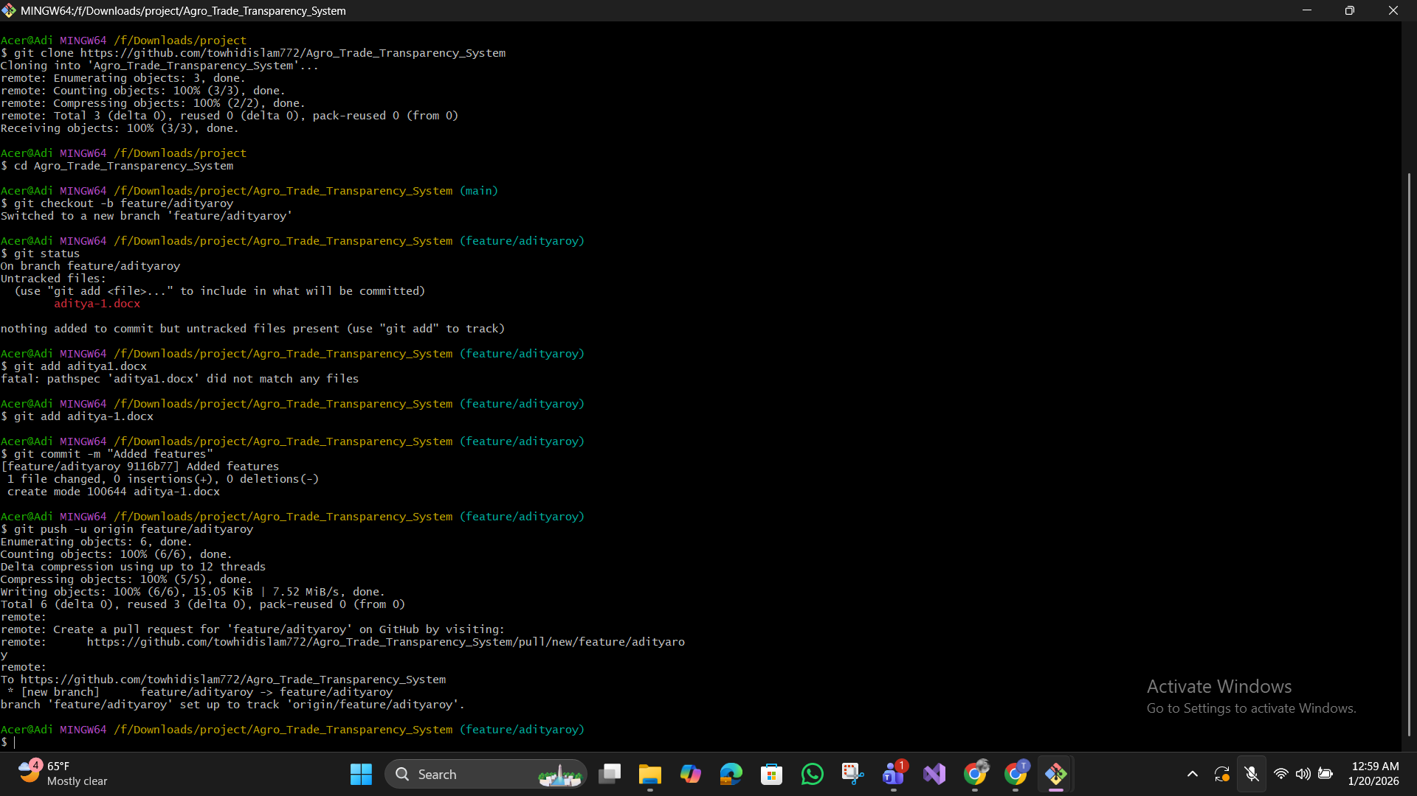

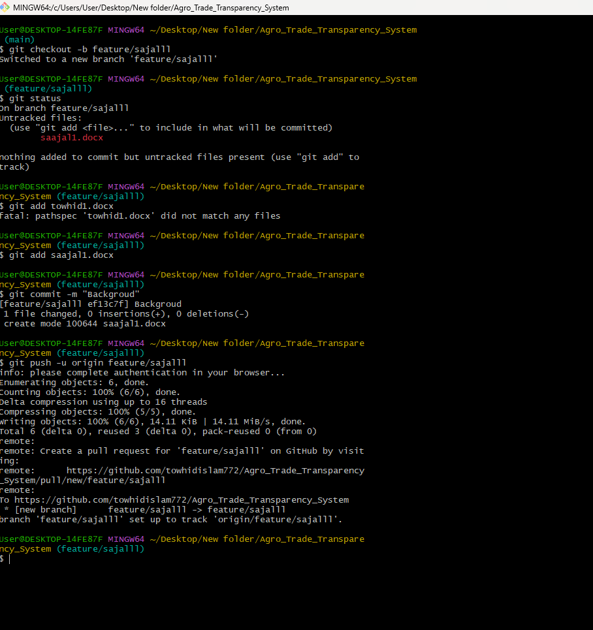

**Pull & Merge Request :**

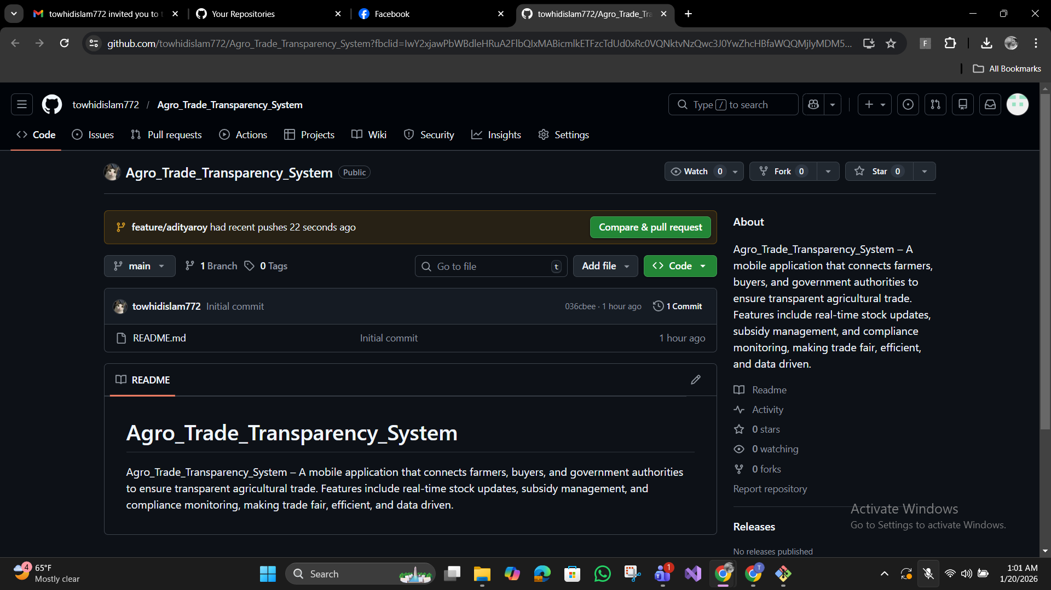

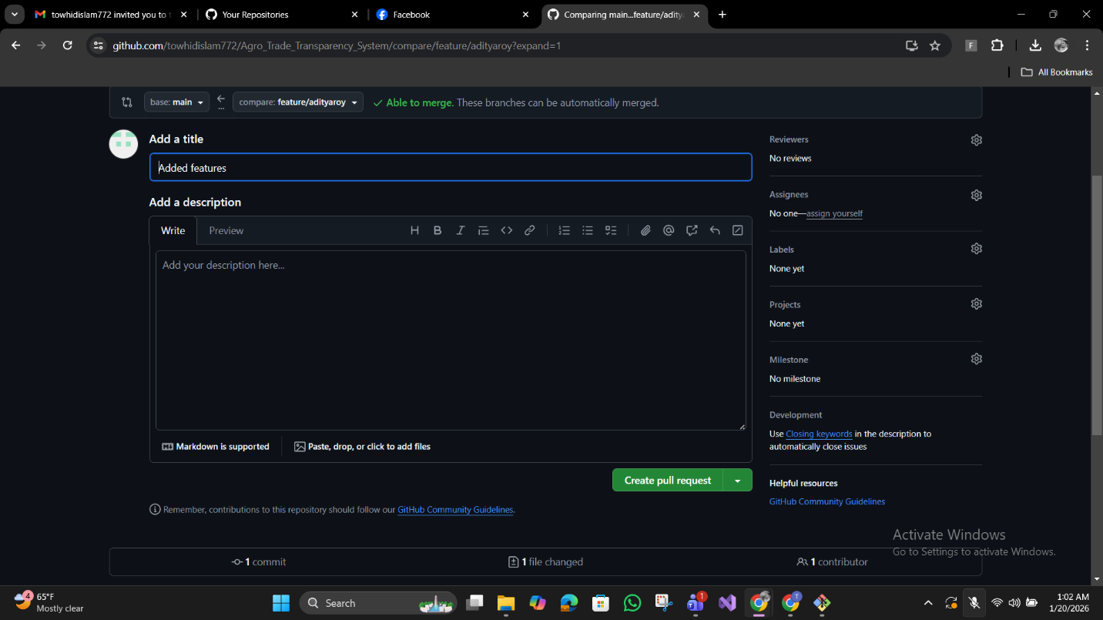

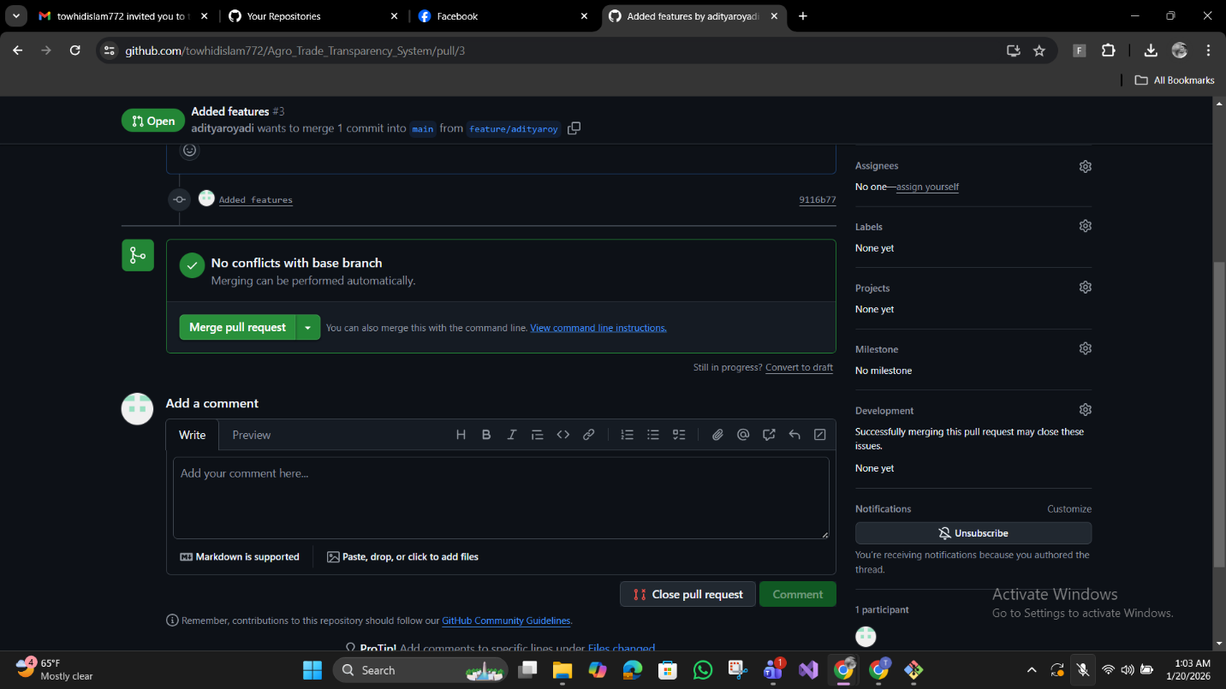

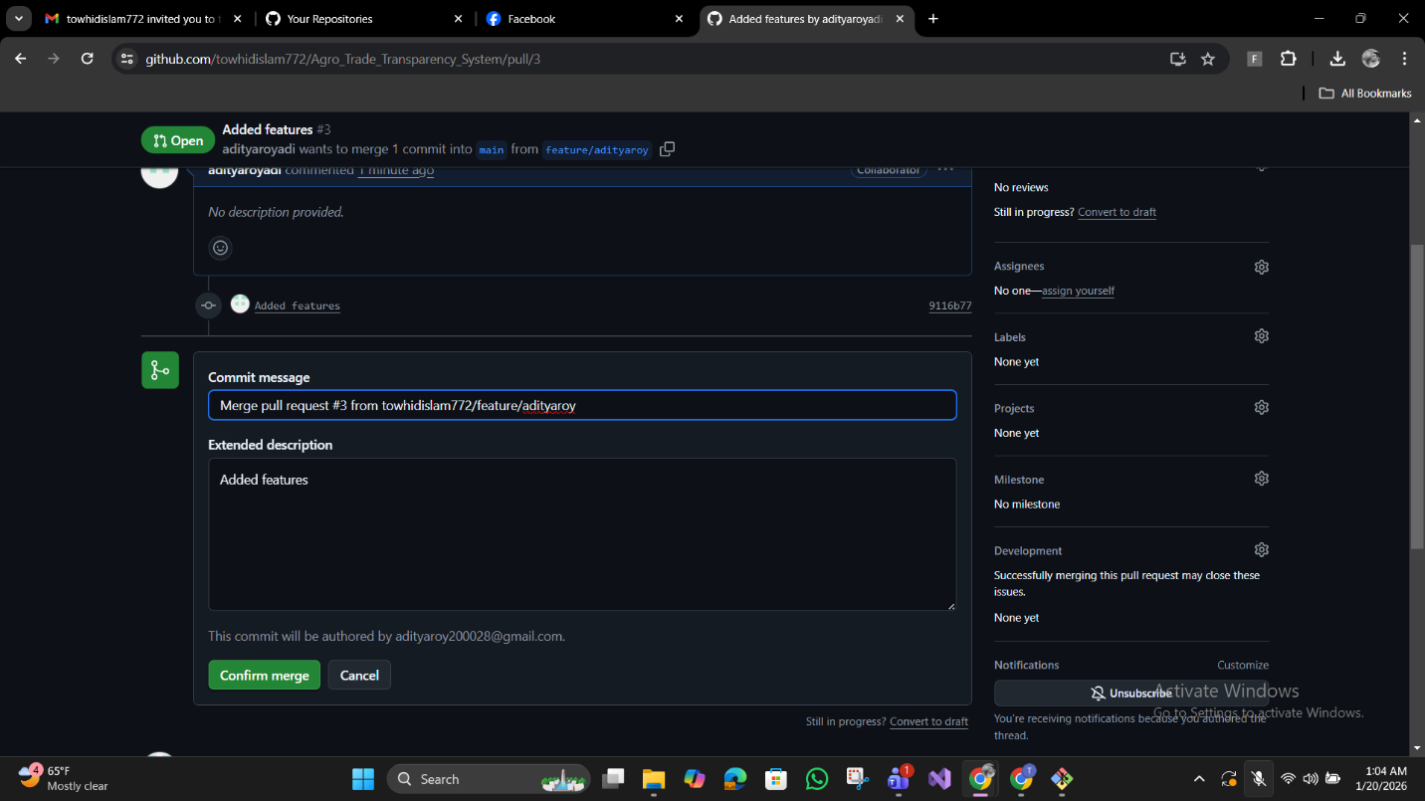

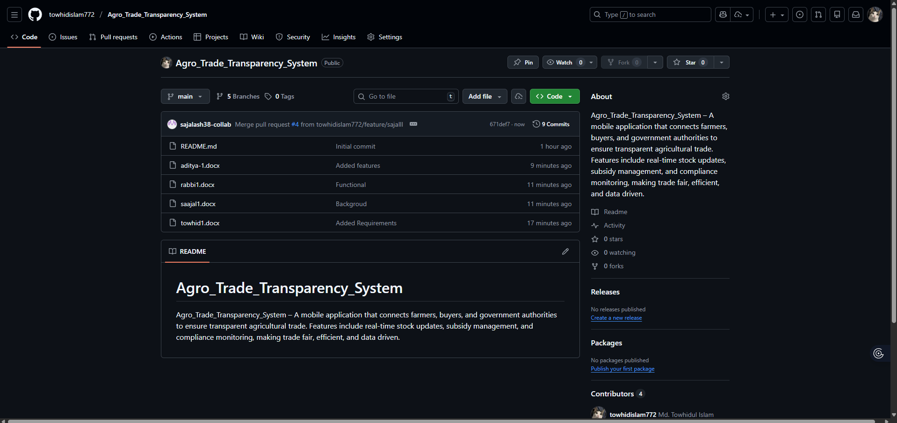

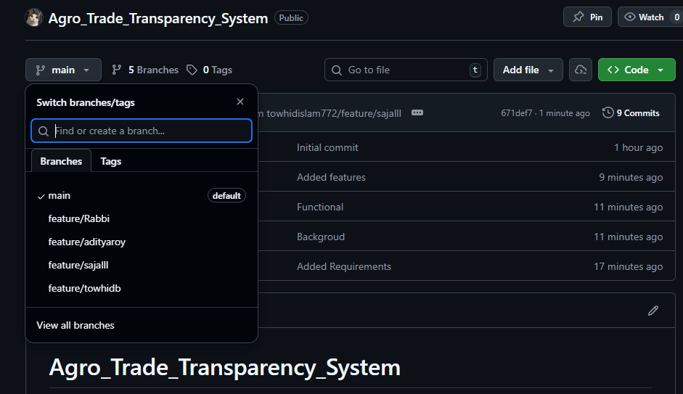

Merge main into branches :

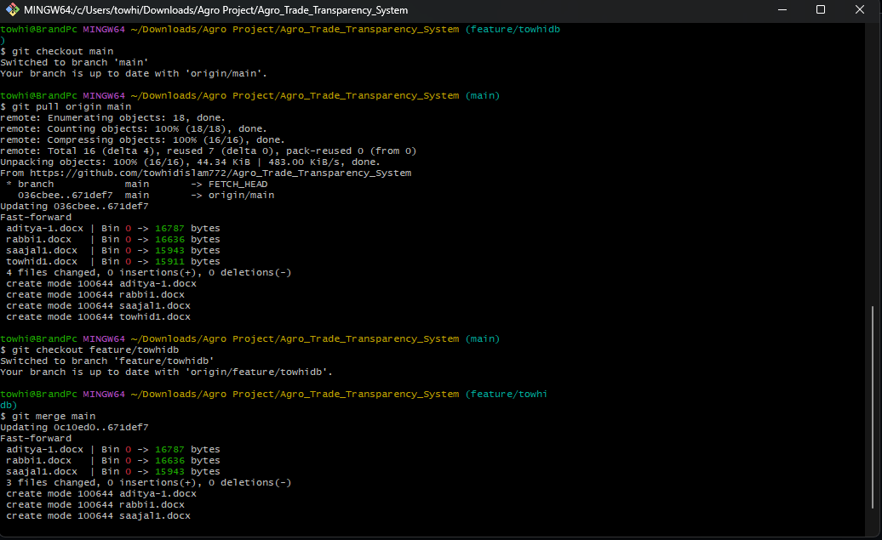

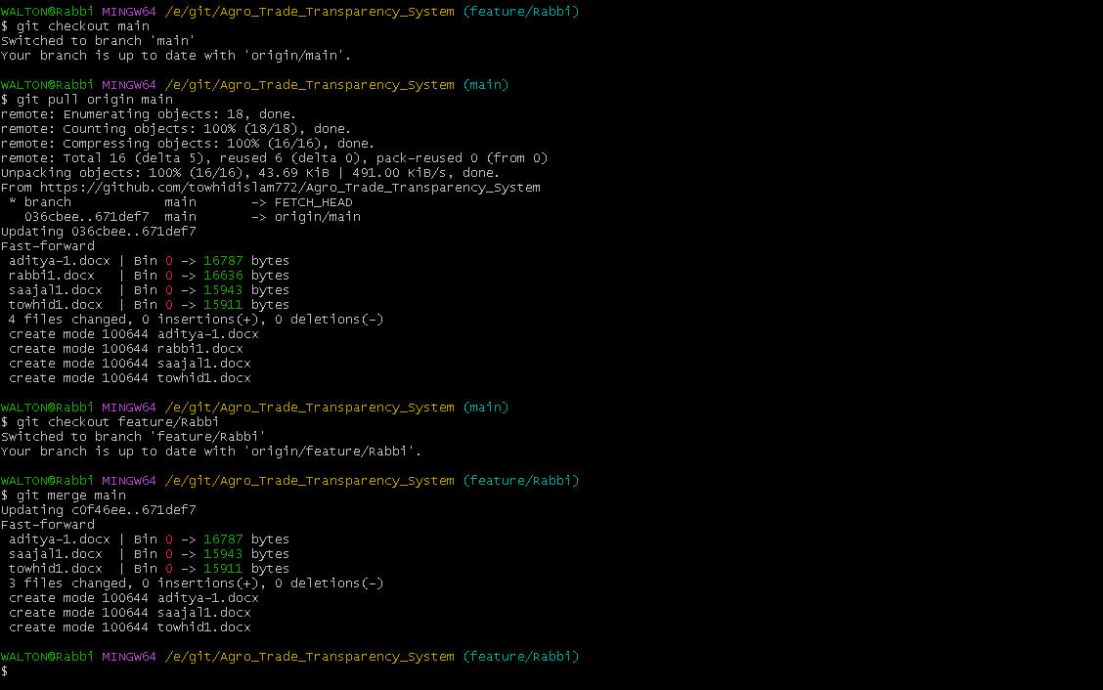

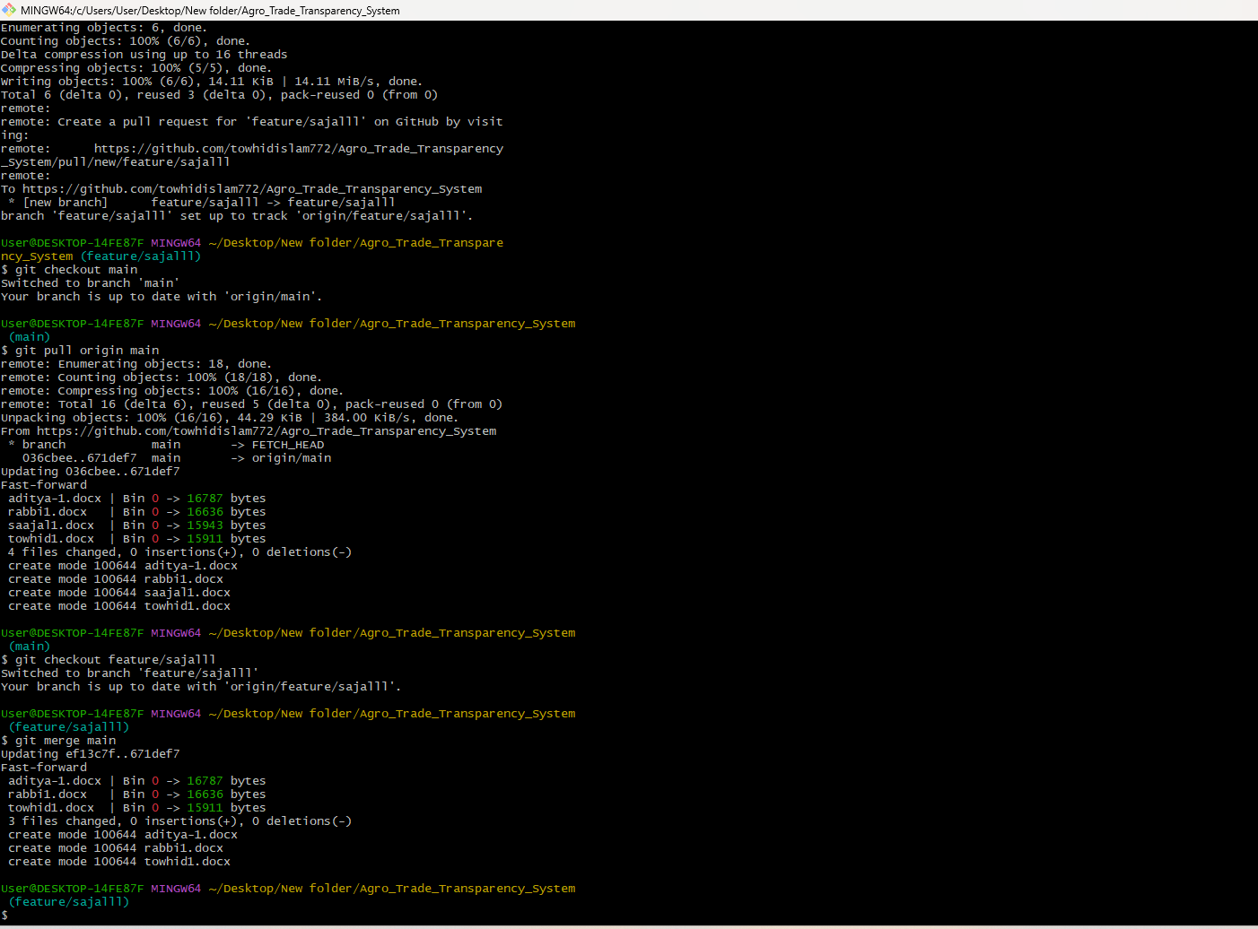

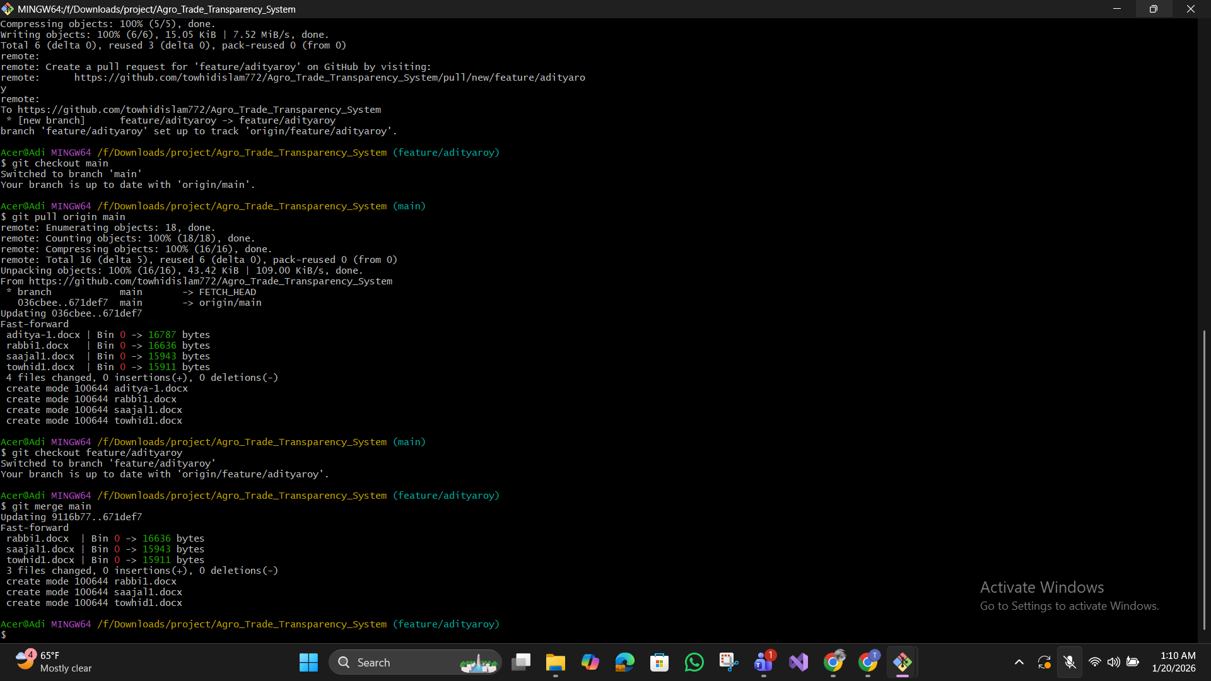

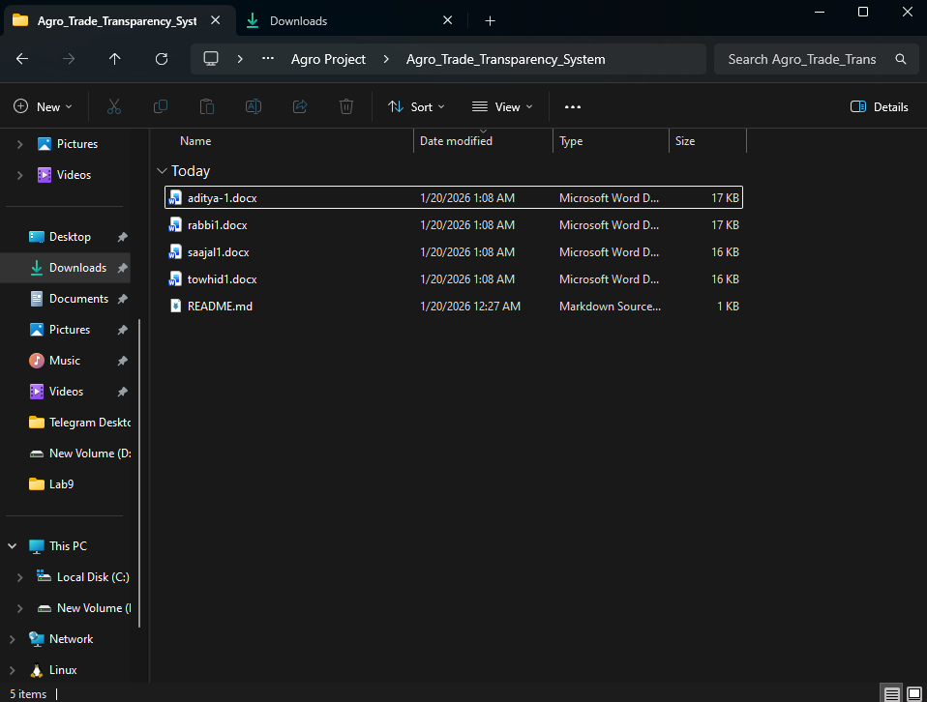

Next push & Pull :

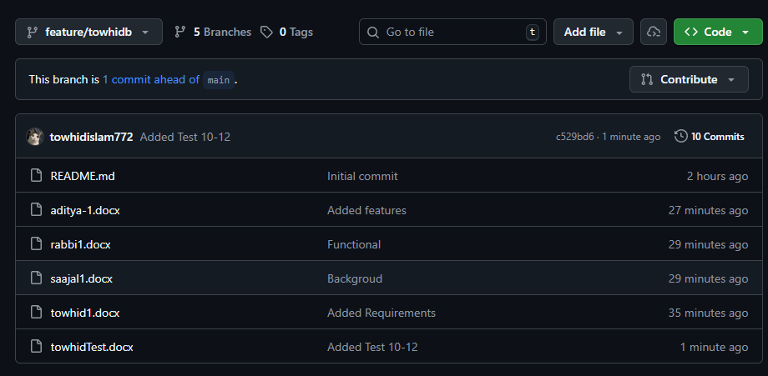

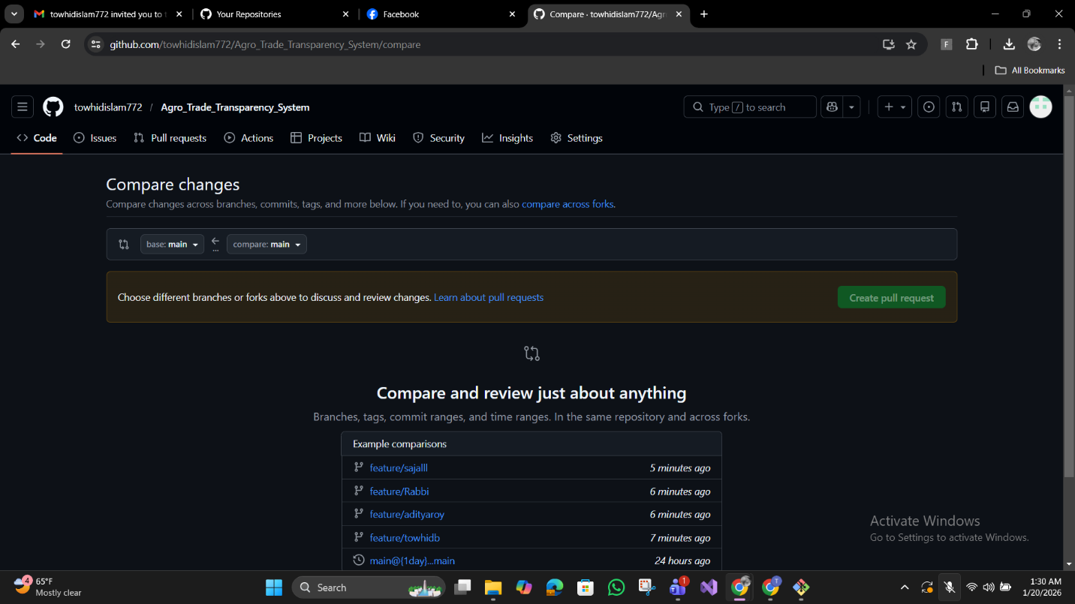

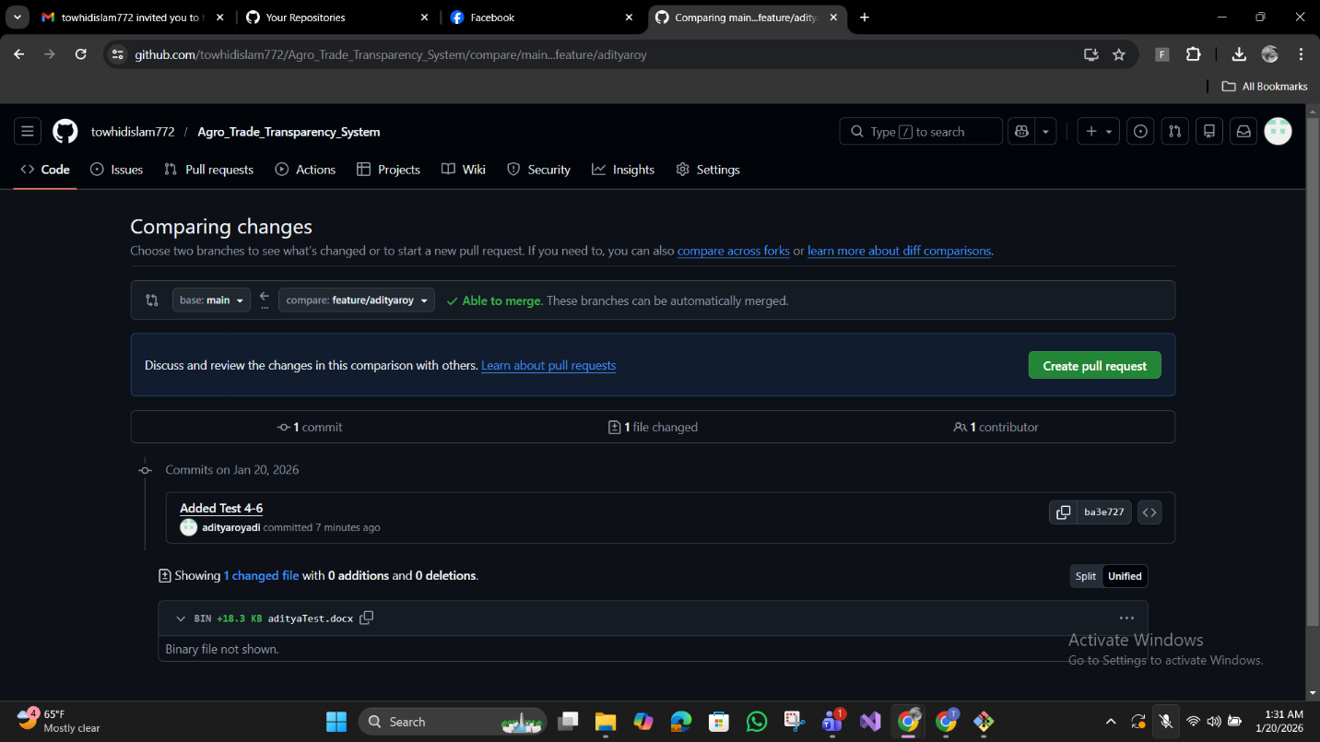

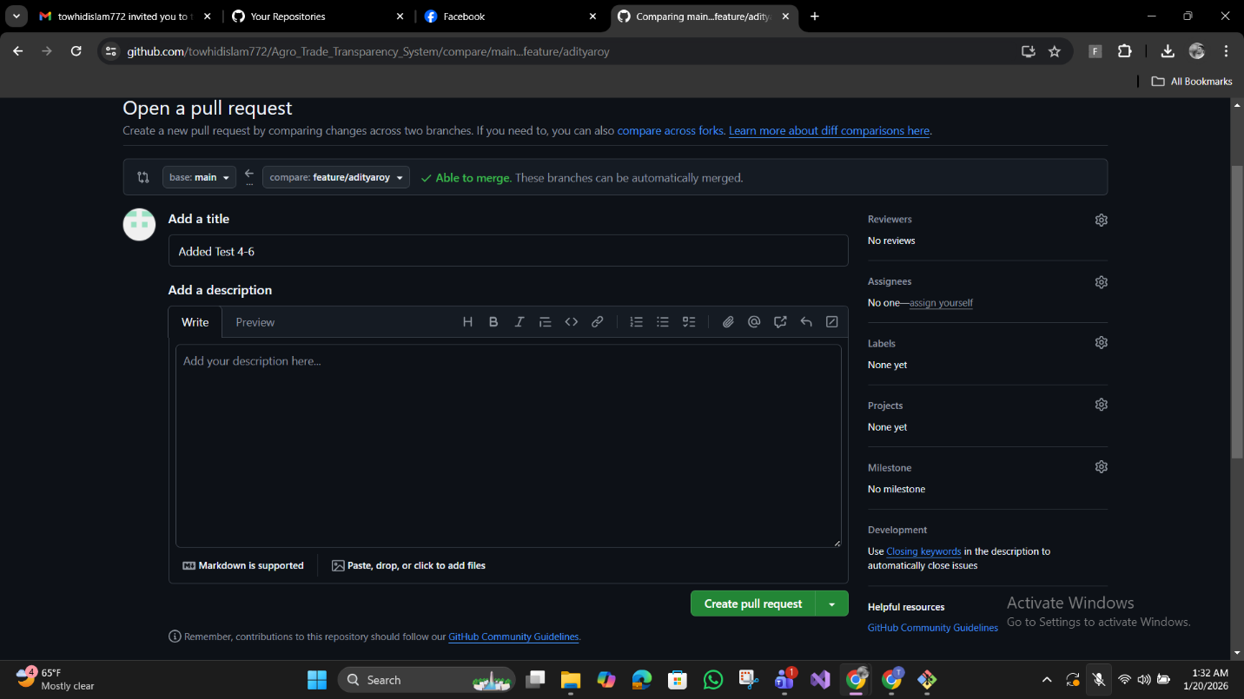

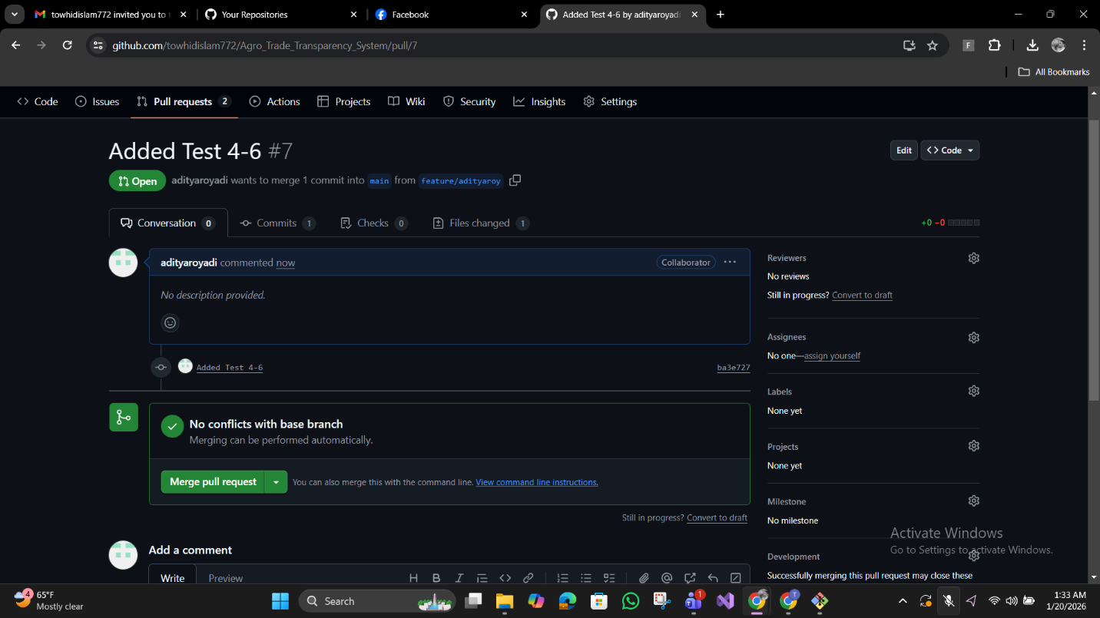

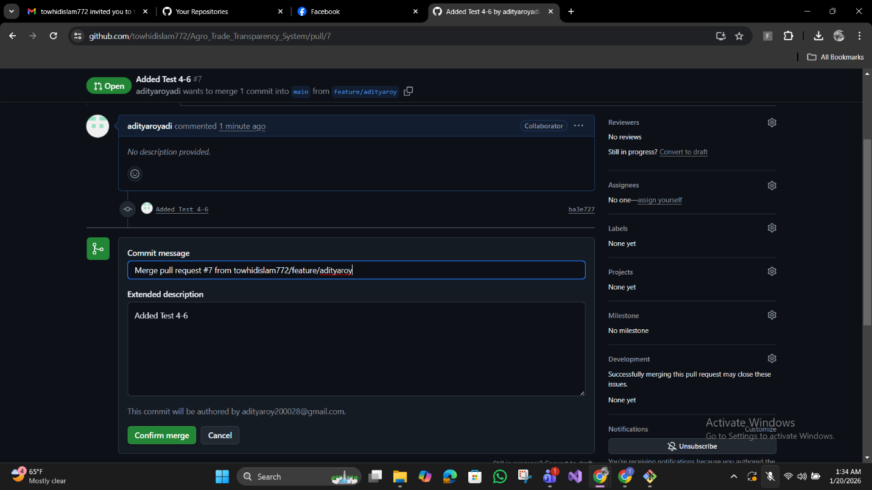

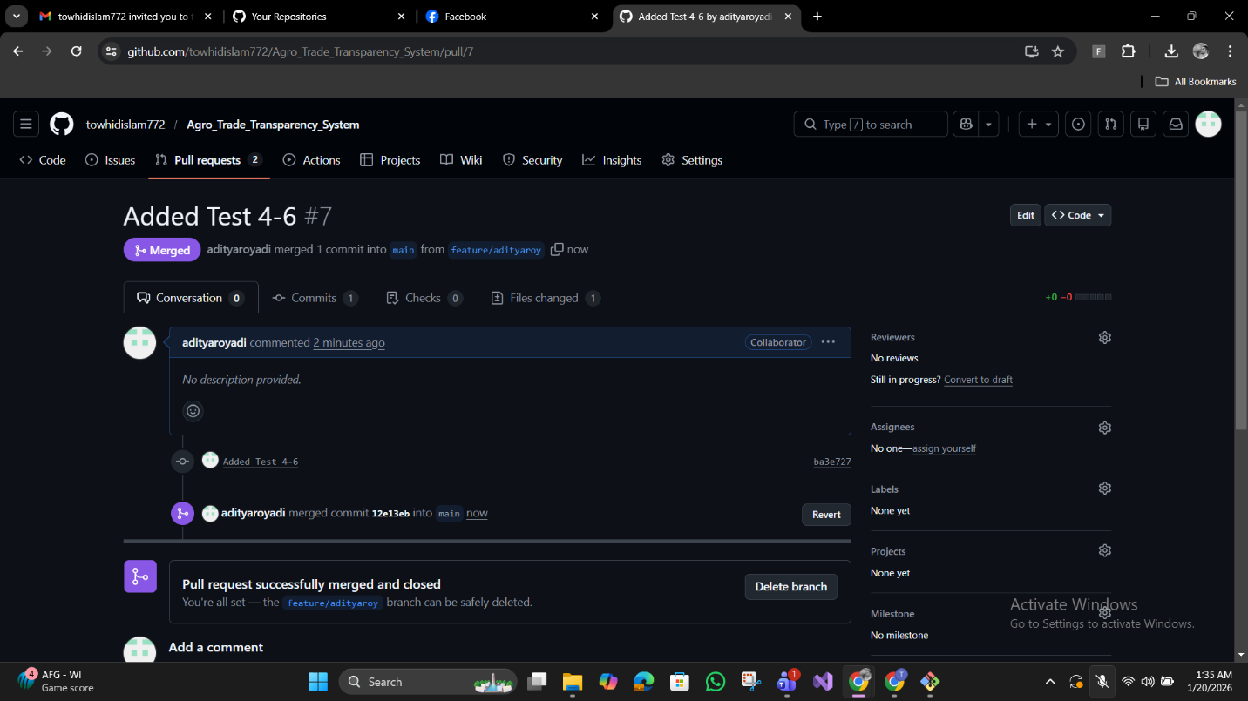

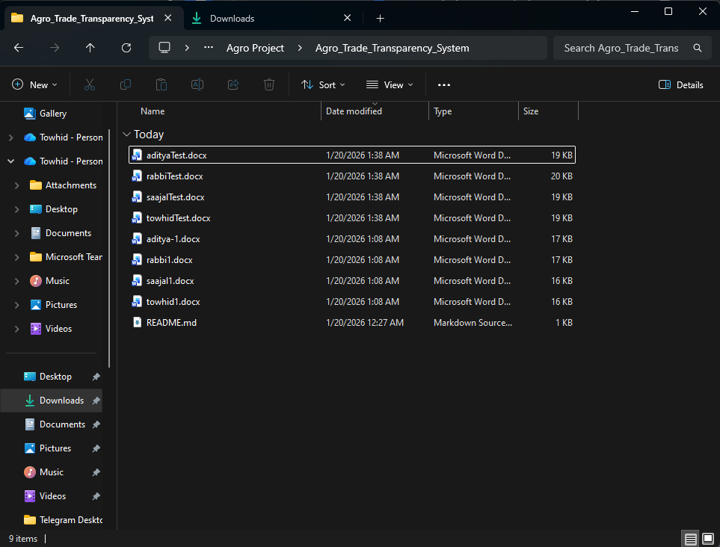

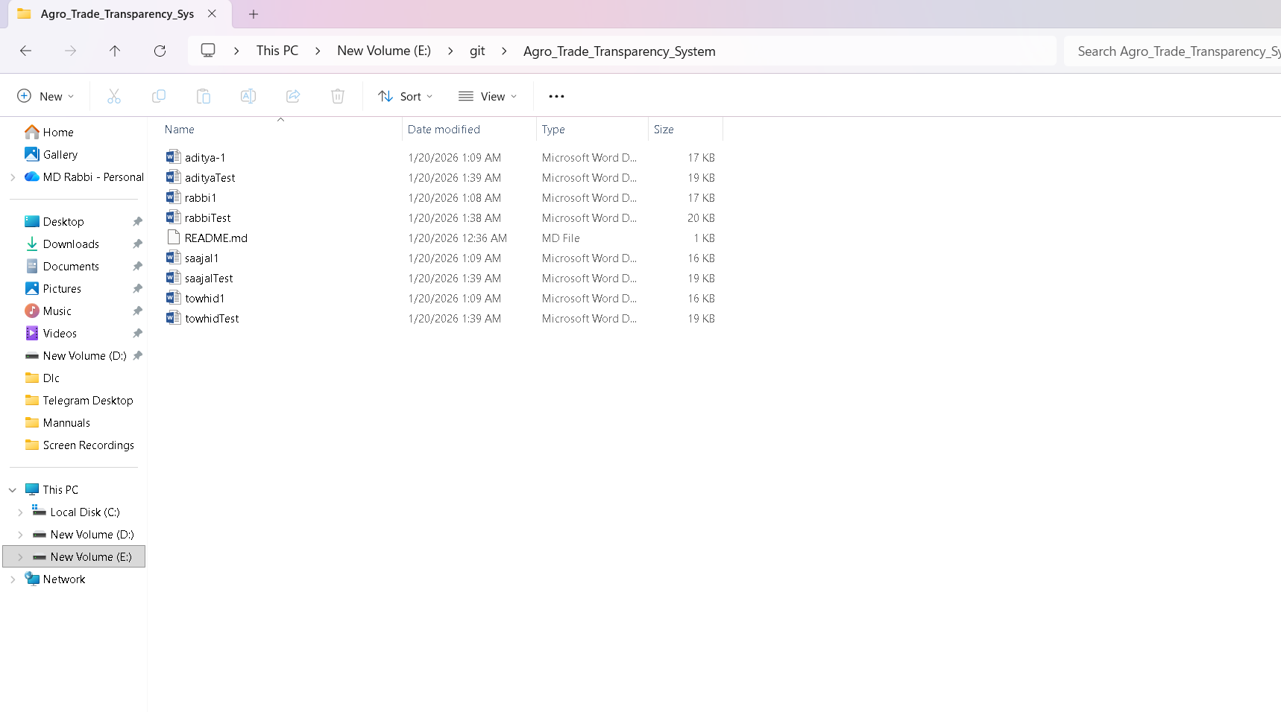

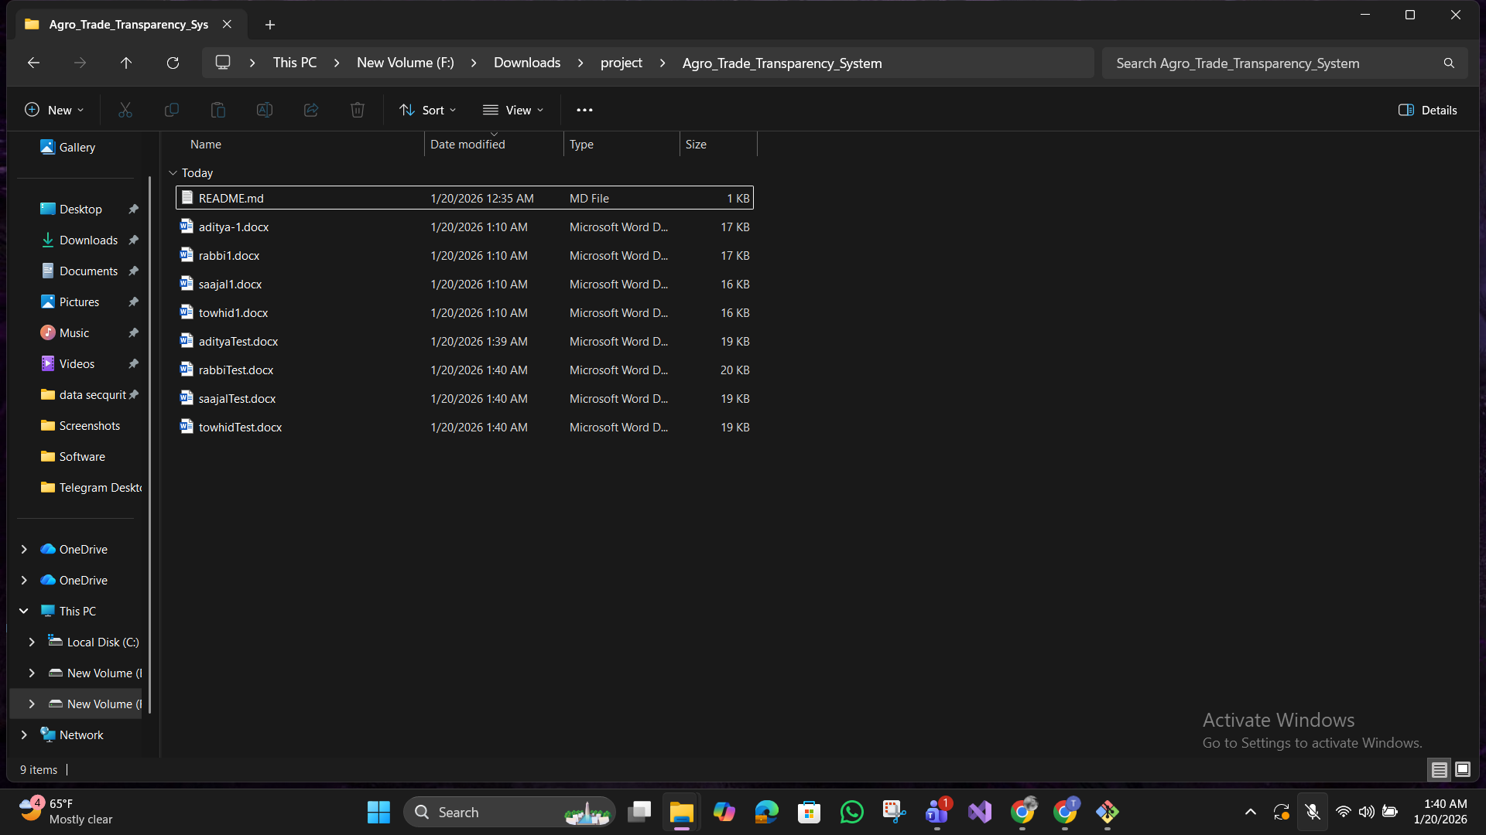

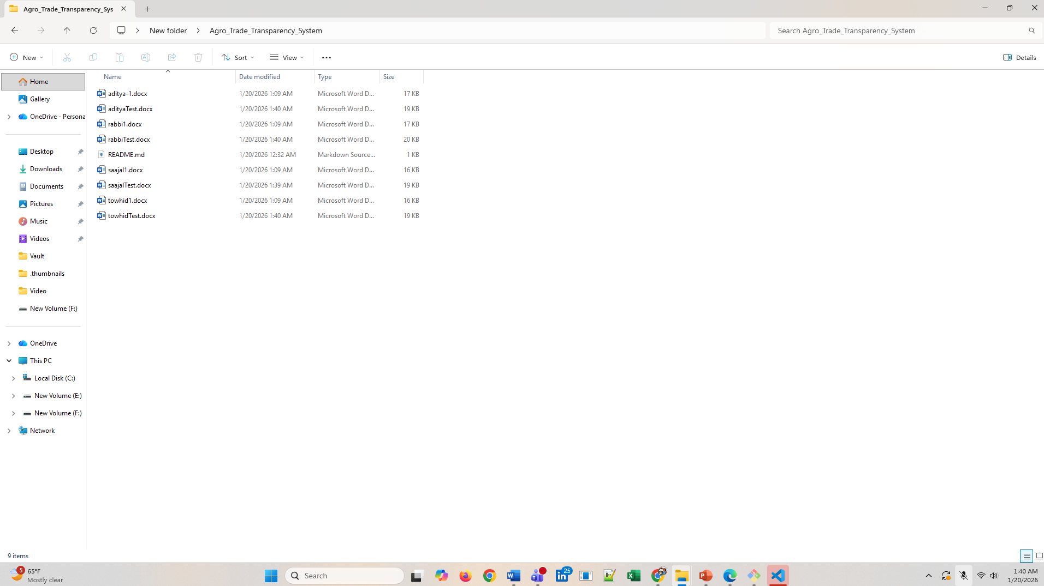

# 5. SOFTWARE TESTING

**1. UNIT TESTING**

Individual developers test their individual components or modules independently before integrating them with the full system.

* Authentication functions (login, registration, OTP)
* Blockchain transaction recording
* Payment processing methods
* Data validation functions

**2. INTEGRATION TESTING**

**Bottom-Up Approach**

Core blockchain and payment modules are critical

* Start with blockchain module
* Integrate payment gateway
* Build up to user interface

**3. REGRESSION TESTING**

Ensure new changes don't break existing features

* After each sprint completion
* After bug fixes
* After adding new payment gateways
* Automated tests for critical workflows

**4. SMOKE TESTING**

Quick verification before detailed testing Daily checks:

* App launches on Android
* User can login
* Transaction can be created
* Payment gateway connects
* Blockchain is accessible

**5. PERFORMANCE TESTING**

Meet non-functional requirements

* 1000 concurrent users support
* App loads in <3 seconds
* Blockchain confirmation <2 seconds
* Low end device performance

**6. SECURITY TESTING**

Protect sensitive data and transactions

* Authentication bypass attempts
* Password and payment data encryption
* Blockchain immutability verification
* OTP security validation

**7. USABILITY TESTING**

Ensure user friendly for rural low literacy users

* Bengali language clarity
* Icon based navigation
* Low end device usability
* Farmer tutorial effectiveness

|  |  |  |  |  |
| --- | --- | --- | --- | --- |
| **Project Name: Agro Trade Transparency System** | | | **Test Designed By : Sajal Kumar Ghosh** | |
| **Test Case ID: TC_1** | | | Test Designed Date : 30/12/2025 | |
| **Test Priority (Low, Medium, High): Medium** | | | Test Executed By: Sajal Kumar Ghosh | |
| **Module Name: Delivery** | | | Test Execution date: 30/12/2025 | |
| **Test Title: Update delivery status** | | |  | |
| **Description: Test the product delivery status update feature.** | | |  | |
| **Precondition: Product is marked as “In Transit” & Buyer and seller exist in the system** | | | | |
| **Dependencies : Active transaction and assigned delivery** | | | | |
| **Test Steps** | **Test Data** | **Expected Results** | **Actual Result** | **Status (Pass/Fail)** |
| 1. **Go to the delivery dashboard** 2. **Select an active delivery** 3. **Choose delivery status** 4. **Update status to "In Transit"** 5. **Click update** | Status: In Transit Delivery ID: D1234 Product: Rice 50kg | Delivery status is updated successfully and reflected in farmer and buyer dashboards | As expected | Pass |

|  |  |  |  |  |
| --- | --- | --- | --- | --- |
| **Project Name: Agro Trade Transparency System** | | | **Test Designed By : Sajal Kumar Ghosh** | |
| **Test Case ID: TC_2** | | | Test Designed Date : 30/12/2025 | |
| **Test Priority (Low, Medium, High): High** | | | Test Executed By: Sajal Kumar Ghosh | |
| **Module Name: Product Purchase** | | | Test Execution date: 30/12/2025 | |
| **Test Title: Complete product purchase from listing to payment** | | |  | |
| **Description: Test the end-to-end product purchase workflow for buyers to acquire agricultural products.** | | |  | |
| **Precondition: User is logged in as a buyer or consumer, products are available in the marketplace, and the buyer has sufficient wallet balance or a linked payment method.** | | | | |
| **Dependencies : Product listing, payment gateway, transaction recording system** | | | | |
| **Test Steps** | **Test Data** | **Expected Results** | **Actual Result** | **Status (Pass/Fail)** |
| 1. **Browse available products** 2. **Select desired product** 3. **View product details** 4. **View product details** 5. **Select payment method** 6. **Complete payment** 7. **Receive confirmation** | Product: Fresh Tomatoes Quantity: 30kg Price: BDT 40/kg Total: BDT 1200 Seller: Farmer F456 Payment: bKash | Purchase completed: - Order confirmation shown - Payment processed successfully - Transaction recorded on blockchain  -Receipt generated - Transaction ID assigned | As expected | Pass |

|  |  |  |  |  |
| --- | --- | --- | --- | --- |
| **Project Name: Agro Trade Transparency System** | | | **Test Designed By : Sajal Kumar Ghosh** | |
| **Test Case ID: TC_3** | | | Test Designed Date : 30/12/2025 | |
| **Test Priority (Low, Medium, High): HIgh** | | | Test Executed By: Sajal Kumar Ghosh | |
| **Module Name: Market Price Monitoring** | | | Test Execution date: 30/12/2025 | |
| **Test Title: Real time market price visibility for fair pricing** | | |  | |
| **Description: Test the market price monitoring dashboard for transparency and price manipulation detection.** | | |  | |
| **Precondition: User is logged in as a government official, multiple transactions exist in the system, and price monitoring data is available.** | | | | |
| **Dependencies : Active transactions, blockchain price records** | | | | |
| **Test Steps** | **Test Data** | **Expected Results** | **Actual Result** | **Status (Pass/Fail)** |
| 1. **Navigate to Market Price section** 2. **Select product type** 3. **View current average price** 4. **Check historical price** | Product: Rice Region: Naogaon Date Range: Last 30 days | System displays: - Current average price per kg - Historical price | As expected | Pass |

|  |  |  |  |  |
| --- | --- | --- | --- | --- |
| **Project Name: Agro Trade Transparency System** | | | **Test Designed By : Aditya Roy** | |
| **Test Case ID: TC_4** | | | Test Designed Date : 30/12/2025 | |
| **Test Priority (Low, Medium, High): Medium** | | | Test Executed By: Aditya Roy | |
| **Module Name: Digital Transaction Recording** | | | Test Execution date: 30/12/2025 | |
| **Test Title: Record transaction with digital ID generation** | | |  | |
| **Description: Test the transaction recording system with automatic digital ID creation.** | | |  | |
| **Precondition: Farmer and buyer are registered users, both are logged in, and the product is listed for sale.** | | | | |
| **Dependencies : Blockchain integration, user authentication** | | | | |
| **Test Steps** | **Test Data** | **Expected Results** | **Actual Result** | **Status (Pass/Fail)** |
| 1. **Farmer selects product to sell** 2. **Enter transaction details** 3. **Buyer confirms purchase** 4. **Initiate trade transaction** | Seller ID: F123 Buyer ID: B456 Product: Potatoes Quantity: 100kg Price: BDT 3000 | Transaction recorded with: - Unique Transaction ID - Timestamp - Immutable blockchain entry - Digital signatures - All party details | As expected | Pass |

|  |  |  |  |  |
| --- | --- | --- | --- | --- |
| **Project Name: Agro Trade Transparency System** | | | **Test Designed By : Aditya Roy** | |
| **Test Case ID: TC_5** | | | Test Designed Date : 30/12/2025 | |
| **Test Priority (Low, Medium, High): Medium** | | | Test Executed By: Aditya Roy | |
| **Module Name: User Profile Management** | | | Test Execution date: 30/12/2025 | |
| **Test Title: Role based profile customization** | | |  | |
| **Description: Test user profile management with role based access control.** | | |  | |
| **Precondition: User has completed registration and is logged in.** | | | | |
| **Dependencies : Authentication system, file upload capability** | | | | |
| **Test Steps** | **Test Data** | **Expected Results** | **Actual Result** | **Status (Pass/Fail)** |
| 1. **Navigate to Profile section** 2. **Navigate to Profile section** 3. **Select user role** 4. **Save profile** | Name: Karim Ahmed Mobile: 01712345678 Role: Farmer Location: Rajshahi | Profile saved with: - Updated information - Role-specific dashboard access | As expected | Pass |

|  |  |  |  |  |
| --- | --- | --- | --- | --- |
| **Project Name: Agro Trade Transparency System** | | | **Test Designed By : Aditya Roy** | |
| **Test Case ID: TC_6** | | | Test Designed Date : 30/12/2025 | |
| **Test Priority (Low, Medium, High): High** | | | Test Executed By: Aditya Roy | |
| **Module Name: Mobile Wallet Payment** | | | Test Execution date: 30/12/2025 | |
| **Test Title: Process payment through mobile wallet with transaction receipt** | | |  | |
| **Description: Test mobile wallet integration for cashless micro transactions.** | | |  | |
| **Precondition: User has a linked mobile wallet account, sufficient balance in the wallet, and a transaction has been initiated.** | | | | |
| **Dependencies : bKash/Nagad API integration, active internet connection** | | | | |
| **Test Steps** | **Test Data** | **Expected Results** | **Actual Result** | **Status (Pass/Fail)** |
| 1. **Navigate to Payment section** 2. **Select mobile wallet (bKash)** 3. **Enter wallet number** 4. **Confirm transaction amount** 5. **Enter PIN** 6. **Verify payment** 7. **Generate receipt** | Wallet: bKash Number: 01812345678 Amount: BDT 2500 PIN: **** Transaction ID: TX5678 | Payment processed: - Balance deducted from buyer - Amount credited to seller - Transaction receipt generated | As expected | Pass |

|  |  |  |  |  |
| --- | --- | --- | --- | --- |
| **Project Name: Agro Trade Transparency System** | | | **Test Designed By : Md. Rabbi Ahmed** | |
| **Test Case ID: TC_7** | | | Test Designed Date : 30/12/2025 | |
| **Test Priority (Low, Medium, High): HIgh** | | | Test Executed By: **Md. Rabbi Ahmed** | |
| **Module Name: Government Oversight** | | | Test Execution date: 30/12/2025 | |
| **Test Title: Government access to compliance verification** | | |  | |
| **Description: Test government dashboard for regulatory compliance monitoring and fraud detection.** | | |  | |
| **Precondition: User is logged in as a government official, multiple transactions exist in the system, and price monitoring data is available.** | | | | |
| **Dependencies : Updated delivery status** | | | | |
| **Test Steps** | **Test Data** | **Expected Results** | **Actual Result** | **Status (Pass/Fail)** |
| 1. **Log in as Government Official** 2. **Open Compliance Dashboard** 3. **View flagged transactions** 4. **Generate compliance report** | Role: Government Official Product: Rice Region: All Date: Last 7 days Price Deviation: >20% | Dashboard displays: - Flagged transactions - Price manipulation  - Stock verification data - Subsidy distribution status - Exportable reports | As expected | Pass |

|  |  |  |  |  |
| --- | --- | --- | --- | --- |
| **Project Name: Agro Trade Transparency System** | | | **Test Designed By : Md. Rabbi Ahmed** | |
| **Test Case ID: TC_8** | | | Test Designed Date : 30/12/2025 | |
| **Test Priority (Low, Medium, High): Medium, High** | | | Test Executed By: Md. Rabbi Ahmed | |
| **Module Name: Bengali Language Support** | | | Test Execution date: 30/12/2025 | |
| **Test Title: Complete Bengali interface rendering** | | |  | |
| **Description: Test the product delivery confirmation feature.** | | |  | |
| **Precondition: The app is installed, and the user has access to the application.** | | | | |
| **Dependencies : Test full Bengali language support for low literacy users.** | | | | |
| **Test Steps** | **Test Data** | **Expected Results** | **Actual Result** | **Status (Pass/Fail)** |
| 1. **Open application** 2. **Select Bengali (বাংলা)** | Language: Bengali (বাংলা) | All interface elements display in Bengali: - Menus and navigation - Button labels - Form fields - Error messages - Tutorial content - Help documentation | As expected | Pass |

|  |  |  |  |  |
| --- | --- | --- | --- | --- |
| **Project Name: Agro Trade Transparency System** | | | **Test Designed By : Md. Rabbi Ahmed** | |
| **Test Case ID: TC_9** | | | Test Designed Date : 30/12/2025 | |
| **Test Priority (Low, Medium, High): High** | | | Test Executed By: Md. Rabbi Ahmed | |
| **Module Name: Product Listing** | | | Test Execution date: 30/12/2025 | |
| **Test Title: Farmer lists product for sale with market price visibility** | | |  | |
| **Description: Test product listing functionality with automatic market price suggestions.** | | |  | |
| **Precondition: User is logged in as a farmer, the farmer profile is complete, and market price data is available.** | | | | |
| **Dependencies : Product database, market price algorithm** | | | | |
| **Test Steps** | **Test Data** | **Expected Results** | **Actual Result** | **Status (Pass/Fail)** |
| 1. **Navigate to "Add Product"** 2. **Navigate to "List Product"** 3. **Enter quantity and quality** 4. **Set selling price** 5. **Upload product photo** 6. **Submit listing** | Product: Tomatoes Quantity: 50kg Quality: Grade A Set Price: BDT 38/kg Photo: tomatoes.jpg | Product listed successfully: - Visible to buyers - Market price displayed - Product details recorded - Photo uploaded  - Traceability ID assigned | As expected | Pass |

|  |  |  |  |  |
| --- | --- | --- | --- | --- |
| **Project Name: Agro Trade Transparency System** | | | **Test Designed By : Md. Towhidul Islam** | |
| **Test Case ID: TC_10** | | | Test Designed Date : 30/12/2025 | |
| **Test Priority (Low, Medium, High): Medium, High** | | | Test Executed By: Md. Towhidul Islam | |
| **Module Name: Product Search and Browse** | | | Test Execution date: 30/12/2025 | |
| **Test Title: Browse and search products with filtering options** | | |  | |
| **Description: Test the product browsing and search functionality for buyers to discover available agricultural products.** | | |  | |
| **Precondition: User is logged in as Buyer, Retailer, or Consumer; multiple products are listed in the marketplace; products have complete details.** | | | | |
| **Dependencies : Product database, search algorithm, filtering system** | | | | |
| **Test Steps** | **Test Data** | **Expected Results** | **Actual Result** | **Status (Pass/Fail)** |
| 1. **Navigate to Product Marketplace** 2. **Browse product list** 3. **Apply filters** 4. **View product details** 5. **Check farmer information** 6. **View product images** 7. **Check availability status** | Filter: Category - Grains Price Range: BDT 30-50/kg Location: Rajshahi Quality: Grade A | Results display: - Relevant products only - Product name, image, price - Farmer details and location - Quality grade - Available quantity - Market price comparison - Option to view full details | As expected | Pass |

|  |  |  |  |  |
| --- | --- | --- | --- | --- |
| **Project Name: Agro Trade Transparency System** | | | **Test Designed By : Md. Towhidul Islam** | |
| **Test Case ID: TC_11** | | | Test Designed Date : 30/12/2025 | |
| **Test Priority (Low, Medium, High): Medium** | | | Test Executed By: Md. Towhidul Islam | |
| **Module Name: Subsidy Tracking** | | | Test Execution date: 30/12/2025 | |
| **Test Title: Government subsidy distribution and farmer verification** | | |  | |
| **Description: Test the subsidy tracking system to ensure transparent distribution of government aid to farmers.** | | |  | |
| **Precondition: User is logged in as a farmer, the government has initiated a subsidy program, and the farmer is eligible for subsidies.** | | | | |
| **Dependencies : Government subsidy database, blockchain recording, farmer verification system** | | | | |
| **Test Steps** | **Test Data** | **Expected Results** | **Actual Result** | **Status (Pass/Fail)** |
| 1. **Navigate to Subsidy section** 2. **View subsidy history** 3. **Verify disbursement details** 4. **Confirm receipt of funds** | Subsidy Program: Seed Support 2025 Amount: BDT 5000 Disbursement Date: 15/12/2025 Status: Received | Subsidy dashboard displays: - List of all subsidies received - Disbursement amounts - Dates of payment - Program names | As expected | Pass |

|  |  |  |  |  |
| --- | --- | --- | --- | --- |
| **Project Name: Agro Trade Transparency System** | | | **Test Designed By : Md. Towhidul Islam** | |
| **Test Case ID: TC_12** | | | Test Designed Date : 30/12/2025 | |
| **Test Priority (Low, Medium, High): High** | | | Test Executed By: Md. Towhidul Islam | |
| **Module Name: Stock Verification** | | | Test Execution date: 30/12/2025 | |
| **Test Title: Real time stock and product availability tracking** | | |  | |
| **Description: Test supply chain stock verification for government oversight and retailer planning.** | | |  | |
| **Precondition: Products are listed in the system, farmers update stock regularly, and the user has appropriate access rights.** | | | | |
| **Dependencies : Inventory management system, blockchain records** | | | | |
| **Test Steps** | **Test Data** | **Expected Results** | **Actual Result** | **Status (Pass/Fail)** |
| 1. **Navigate to Stock Dashboard** 2. **View current stock levels** 3. **Check product availability** 4. **Generate stock report** | Product: Rice Date: Current | Stock dashboard displays: - Total available stock  - Real time updates | As expected | Pass |

# 6. CONCLUSION

The Agro Trade Transparency System is designed to solve major problems in the traditional agricultural trading process, such as lack of transparency, unfair pricing, payment delays, and middleman exploitation. By using modern digital technologies, this system creates a secure and transparent platform where farmers, traders, buyers, consumers, and government authorities can interact efficiently.

The system ensures fair market prices for farmers by providing real time price information and digital trade records. Secure digital payment integration helps farmers receive payments quickly and safely. Supply chain tracking and product traceability improve trust among buyers and consumers by allowing them to verify product sources. Government monitoring features help reduce fraud, control price manipulation, and support better policy decisions.

Agile Scrum was chosen as the development model to allow flexibility, continuous feedback, and incremental improvement. This approach ensures that user requirements are met effectively and the system can adapt to changing agricultural market conditions.

Overall, the Agro Trade Transparency System improves efficiency, accountability, and trust in agricultural trade. It supports sustainable development in the agricultural sector and has the potential to significantly improve the livelihoods of farmers while strengthening the overall trade ecosystem.